Public CMS

Template Making Manual

1 Introduction to PublicCMS 4
1.1 Profile 4
1.2 License Agreement 4
1.3 Access to PublicCMS 5
2 Template Usage 5
2.1 Overview 5
2.2 Ordinary page template 5
2.3 Category page template 9
2.4 Content page template 16
2.5 Task plan script 20
2.6 Template Fragements 21
2.7 Page Fragements 22
3 Template language 27
3.1 Profile/Overview 27
3.2 Template Syntax 28
3.3 Data instruction extension 29
3.4 Entity Query Instruction 29
3.5 List query instruction 29
3.6 Function Extension 30
3.7 Macro definition 31
3.8 Aliases and scopes 31
3.9 Template manual 31
4 Template data 32
4.1 Common Data 32
4.2 Common Data of Web Templates 33
4.3 Static template common data 33
4.4 Static classification Template Data 33
4.5 Static content Template Data 34
4.6 Recommended bit data 34
4.7 Dynamic template common data 34
4.8 Dynamic Template Parameter Data 35
4.9 Site Configuration Data 35
5 Multiple sites and multiple domain names 36
5.1 Multiple sites 36
5.2 Multiple domain names 38
6 Feature Application 40
6.1 Template Examples 40
6.2 Template Help 42
6.3 Searching and Replacing Templates in Batches 43
6.4 Device Adaptation 44
6.5 Internationalization 47
6.6 Visual layout 50
6.7 Quick Maintenance 52
6.8 Website Access Statistics 54
7 Technical support 54
7.1 Free Technical Support 54
7.2 Commercial Technical Support 55

Introduction to PublicCMS

Profile
PublicCMS is designed based on the latest 2026 Java technology with open source code and structure friendly to SEO. PublicCMS can operate/manage hundreds of thousands of data and PV easily. PublicCMS has been accepted and used by many famous companies and enterprises, and it owns 0.0005% of the total websites of the world. We provide free version and technical support , and we believe PublicCMS will be a good choice for great data website construction and big enterprise projects.
- PublicCMS is suitable for both dynamic website and static website;
- PublicCMS can support multi-site creation, with totally separate data and templates for each website.

License Agreement
- Authorized rights
  - Modify ,Copy and share PublicCMS and its source code;
  - Get free authorization document based on prerequisite agreement, and use PublicCMS in non-business conditions ( for individual user only);
  - Application of PublicCMS in business usage is allowed for at most 3 months. webpages developed must be marked with “Powered by PublicCMS”. The PublicCMS logo and license agreement must appear in an obvious position of the website.
  - Application of PublicCMS in business usage should be authorized by the owner of the software by buying the authorization document. The company authorized should be the final user of the PublicCMS.
  - Licensed users can Modify ,Copy and spread PublicCMS and its source code ;
  - The license agreement applies only to the current version of the PublicCMS, earlier versions have their own license agreement;
- Copyright
  - The copyright of the software belongs to the official owner of the PublicCMS;
- Disclaimer (of warranty)
  - PublicCMS and its affiliated documents are provided with no responsibilities for any possible risk, and can not provide any warranties;
  - Before using PublicCMS, one should fully understand it and assume its possible risks. We won`t provide any technical support or usage warranty, and are not responsible for any risks caused by using PublicCMS unless you have bought the technology support service.

Access to PublicCMS
Executable file download:
https://www.publiccms.com/download.html
PublicCMS source code download:
GITEE: https://gitee.com/sanluan/PublicCMS
GITHUB: https://github.com/sanluan/PublicCMS

Template Usage

Overview
The main usages of template in Public CMS
- ordinary page templates
- content page templates
- category page template
- task plan script
- template fragments
- page fragments
In the construction of a website project, analysis of the three different types of pages (ordinary page, classified page, content page) can help you create a website more quickly and systematically. The flexible use of template fragments, page fragments, task planning script can make your website template logic more reasonable.

Ordinary page template
Ordinary page templates are usually used to display relatively fixed content, such as the home page, about us, contact us, etc.
Such pages are not paginated except for display, and may display a portion of systematic content, such as the latest articles. This type of content usually uses instructions to fetch data directly and present it. There may also be one or more fragmented content, such as the focus map in the home page, the comments section in Contact us, and so on. This kind of fragmented contents usually uses the way of page fragments to achieve the management of these contents.

Dynamic access
To use ordinary template in a dynamic way, you need to set the background template metadata to allow dynamic access.
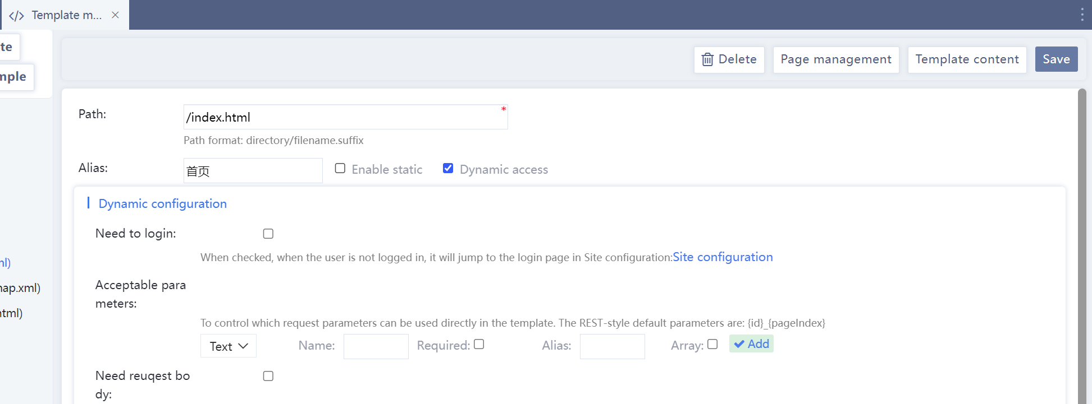

Static
To make an ordinary page template static, enable static in the background template metadata and set the publishing path to the required access path.
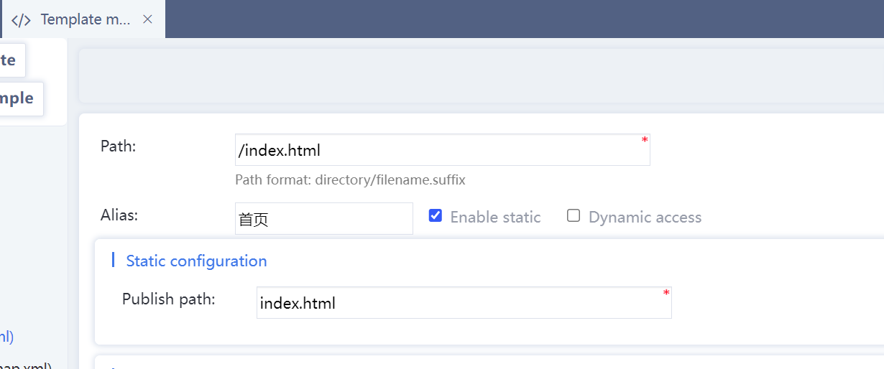

Dynamic template parameter transfer and use
Dynamic template parameter passing is simple. It is similar to dynamic parameter passing in other technologies. As long as you request the template, you add "? Parameter name = parameter value & Parameter name 2= Parameter value 2".
Due to security requirements and cache control requirements, publiccms’s platform site templates need to set acceptable parameters in template metadata.

Parameter types can be text, number, multiline text, content, category, and user.
When the text is selected, the system will automatically process the line break character in the field, and the number will be converted to the numeric type. If the conversion fails, the page request will return 404;
When multiline text is selected, nothing is done to the parameters;
When the content is selected, the system will automatically query the corresponding parameters of the content entity,. when the entity does not exist, has been disabled, or is not on the site, page request return 404;
When the category or the user is selected, the processing logic is similar to the content.
Name is the name of the parameter in the url. If required is checked, a valid parameter must be passed. Otherwise, 404 will be returned.
The alias is the name of the variable in the template. If the parameter is null, use the parameter name as the variable name.
After the array is checked, the variable will exist as an array in the template. You can pass multiple parameters with the same name to pass multiple variables.
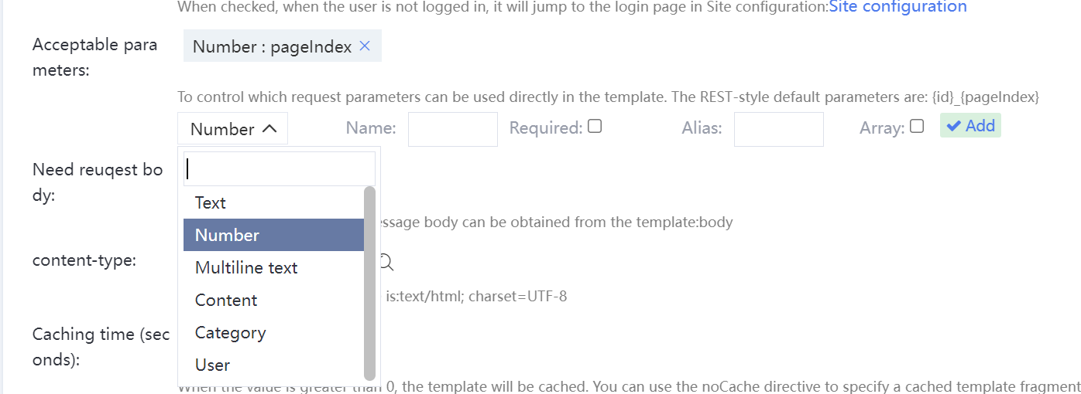
For example, the dynamic template content.html metadata setting allows dynamic access:
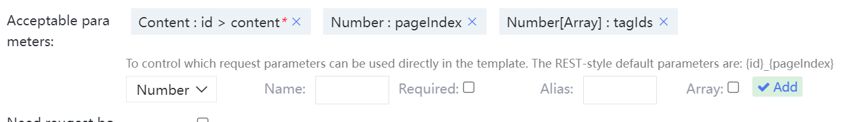
Dynamic request address:
content.html?id=1&pageIndex=2&tagIds=1&tagIds=2&tagIds=3
or REST Style request address：
content/1_2?tagIds=1&tagIds=2&tagIds=3
Use the following variables in template:
${pageIndex} or <@_contentList pageIndex=pageIndex></@_contentList>
The green pageIndex is the variable after converting the url transfer parameter pageIndex to a number. The red pageIndex is the name of the directive parameter
content is the content entity queried by the id of the transfer parameter of url.
<#if tagIds?has_content><#list tagIds as t>${t}<#sep>,</#list></#if>
tagIds is the result of converting the url transfer parameter tagIds into an array

Extended field
Template metadata can be extended in template metadata.
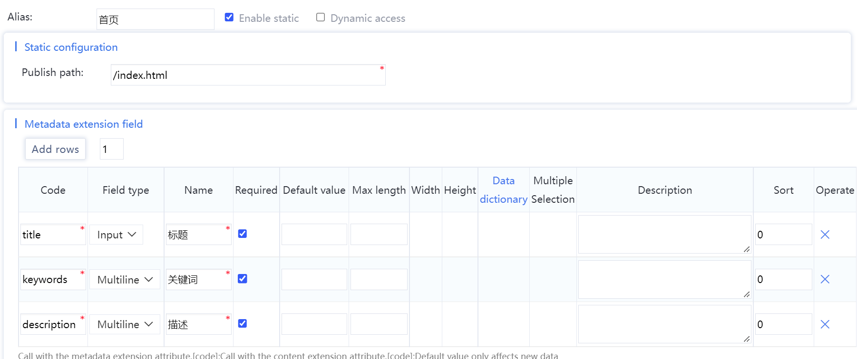
When editing the template, you can click on Template Properties-> Extend the field in the Template Help. Modify the code logic to use these extension fields in an appropriate manner, where all extension field types are stored in string format.
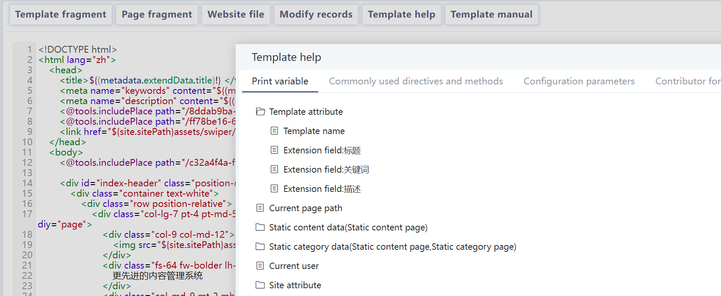
For example, the extention field name ：title
${(metadata.extendData.title)!}

Select this page in Page->Page management for maintainance
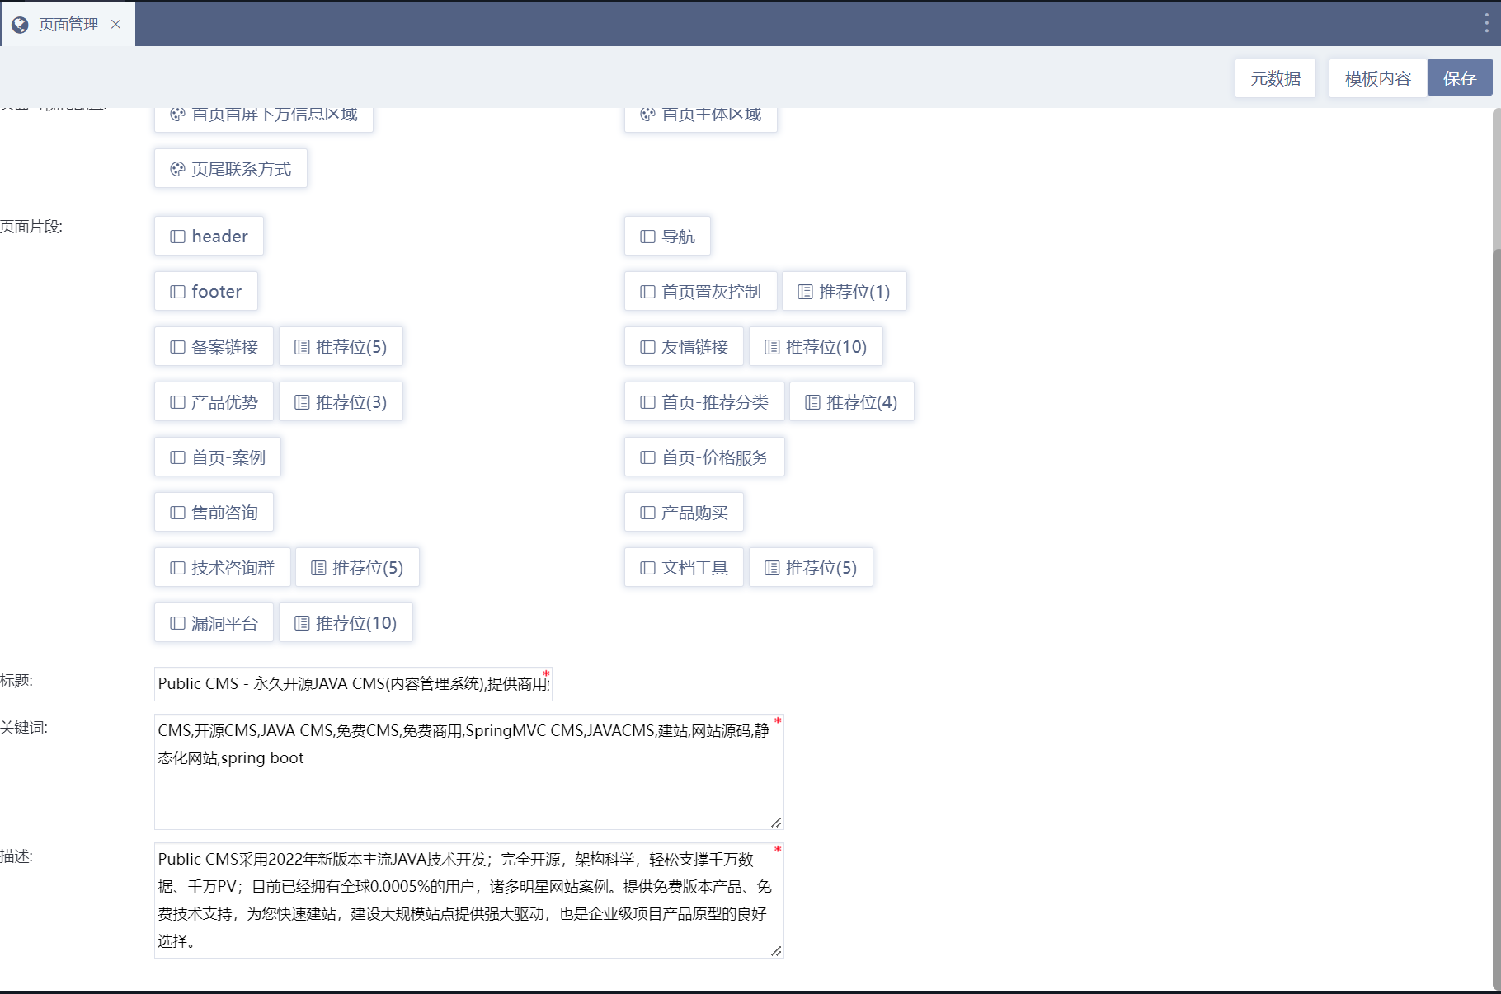

Category page template
The category page template is usually used to display the articles entered in the background and other classified information. The Public CMS supports dynamic display of content and staticize the content for one or more copies.

Dynamic access
In dynamic display, you need pass at least one category id parameter to the template to facilitate the use of directives in the template to get content-related data.
When the category page template is used in dynamic mode, it needs to be set to allow dynamic access in the background template metadata and set acceptable parameters. The category id should be passed to this parameter when the template is used in other templates.
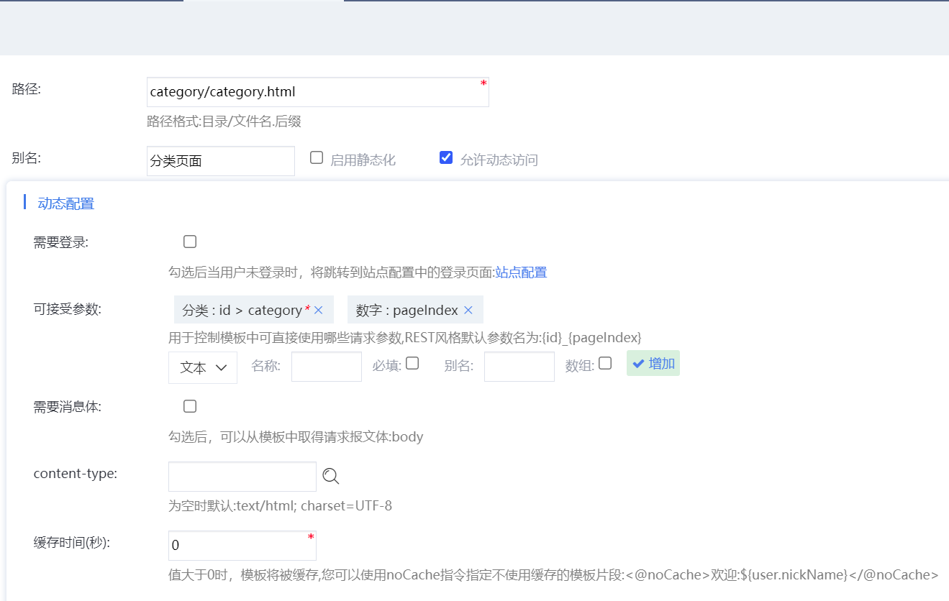
And clear the static template in the category Settings. Set the access path of the category page to the template path above. The parameter name is the acceptable parameter name above, and the value is ${category.id}.
The corresponding dynamic address to the template metadata confugration above: category/category.html?id=${category.id}
or REST style address：category/category/${category.id}

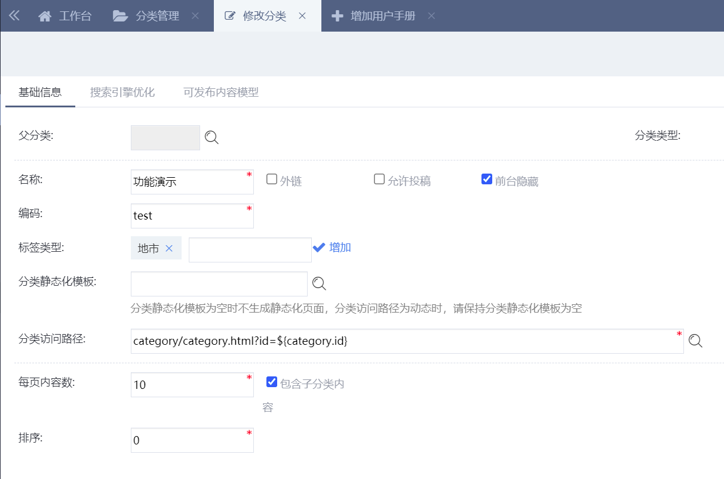

Static
You do not need to select Enable statics for template metadata

To staticize Category page template, you need to set up a static template for category management in the background, and configurate static style Category page accessing path. The configurated template will be used to generate static page for category when the categories are saved, the categories home page is generated in batches, the categories page is generated, and the task plan is generated. 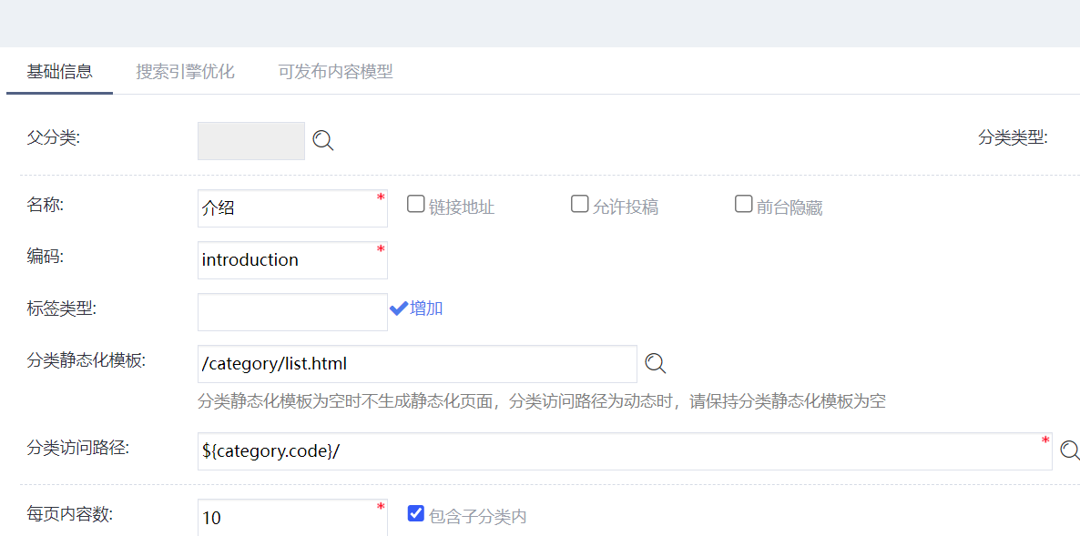

Dynamic Paging
Dynamic paging needs to pass paging parameter name in the third parameter of getPage function.
<div>
<#assign
start=1
end=page.totalPage
/>
<#if (page.pageIndex-5) gt start>
<#assign start=page.pageIndex-4/>
</#if>
<#if (page.pageIndex+5) lt end>
<#assign end=page.pageIndex+4/>
</#if>
<#if !page.firstPage>
<a href="${getPage(category.url,page.prePage,'pageIndex')}">Previous page</a>
<#else>
<span>Previous page</span>
</#if>
<#if start gt 1>
<a href="${category.url}">1</a> ...
</#if>
<#list start..end as n>
<#if n=page.pageIndex>
${n}
<#else>
<a href="${getPage(category.url,n,'pageIndex')}">${n}</a>
</#if>
</#list>
<#if end lt page.totalPage>
... <a href="${getPage(category.url,page.totalPage,'pageIndex')}">${page.totalPage}</a>
</#if>
<#if !page.lastPage>
<a href="${getPage(category.url,page.nextPage,'pageIndex')}">Next page</a>
<#else>
<span>Next page</span>
</#if>
</div>

Static Paging
Static paging only needs to pass the following two parameters : the current page url and page number
<div data-diy="task">
<#assign
start=1
end=page.totalPage
/>
<#if (page.pageIndex-5) gt start>
<#assign start=page.pageIndex-4/>
</#if>
<#if (page.pageIndex+5) lt end>
<#assign end=page.pageIndex+4/>
</#if>
<#if !page.firstPage>
<a href="${getPage(url,page.prePage)}">Previous page</a>
<#else>
<span>Previous page</span>
</#if>
<#if start gt 1>
<a href="${url}">1</a> ...
</#if>
<#list start..end as n>
<#if n=page.pageIndex>
${n}
<#else>
<a href="${getPage(url,n)}">${n}</a>
</#if>
</#list>
<#if end lt page.totalPage>
... <a href="${getPage(url,page.totalPage)}">${page.totalPage}</a>
</#if>
<#if !page.lastPage>
<a href="${getPage(url,page.nextPage)}">Next page</a>
<#else>
<span>Next page</span>
</#if>
</div>

Extension field
You can use category type to manage category extension field.
Modify or add category type in the Setup -> Category type.
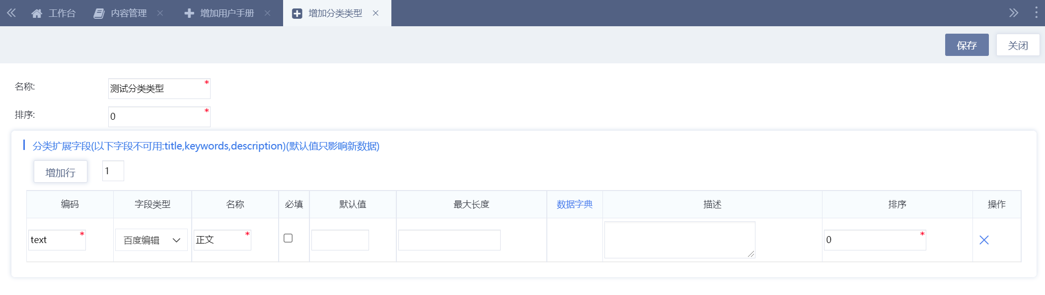
Edit category template, and use extension field. All extended field types are stored in string format.
<#assign attribute=getCategoryAttribute(category.id)/> <#-- On the static category page, you can use attribute objects. On the dynamic category page, you need to obtain attribute objects -->
${(attribute.text?no_esc)!} <#-- To output an editor field, use no_esc to declare no safe escape -->
${getUrl(attribute.url)!} <#-- Attachments need to be converted to absolute paths using getUrl -->
Then in Category Management, add the category selection to add the category type you just created.

You can also change an already created category to this category type. Then double-click the blank area or click the Modify category button to enter the category editing page.
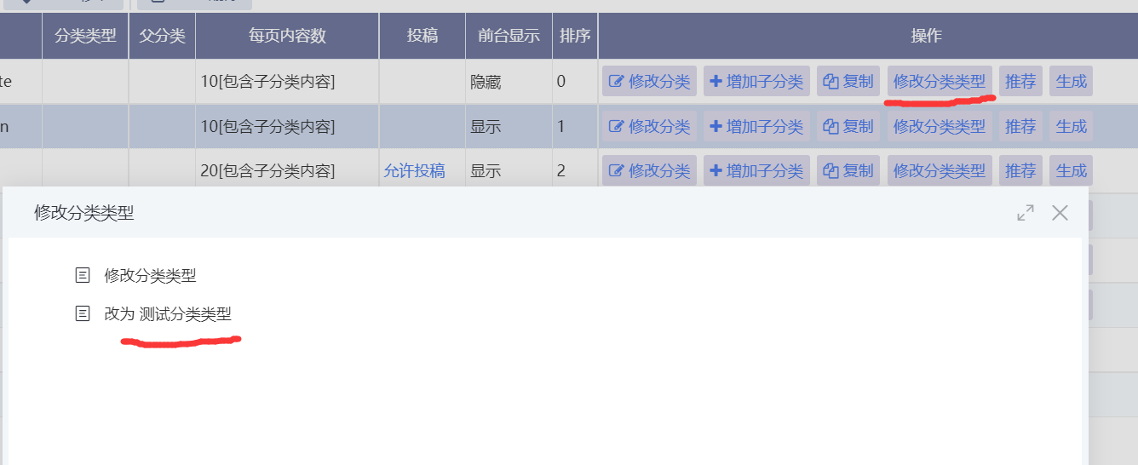
Then you can start to edit the properties you just added.
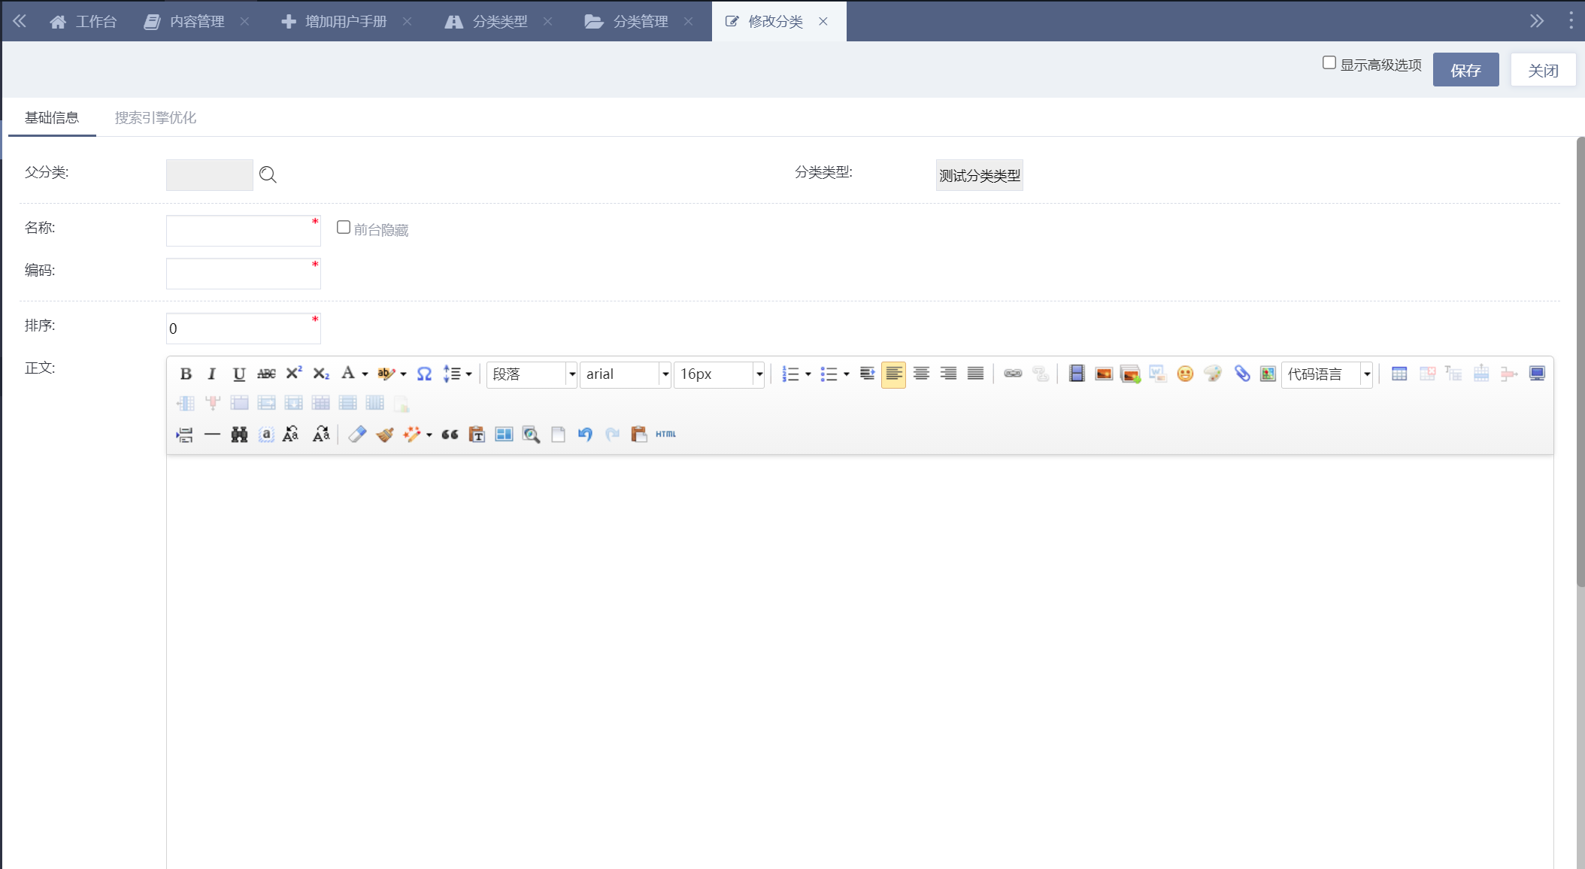

Content contribution
You can set the content contribution function of Category open to allow users submitting content data without logging in the background. The content contribution function requires users to log in the website.
First of all , set up category management to allow contribution.
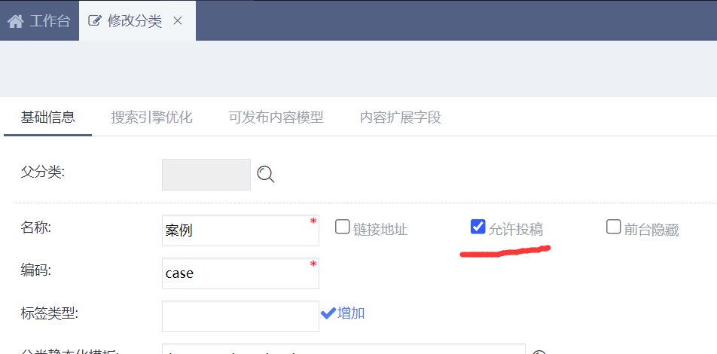
To obtain contribution code in category management or in Template help->Contribution form.
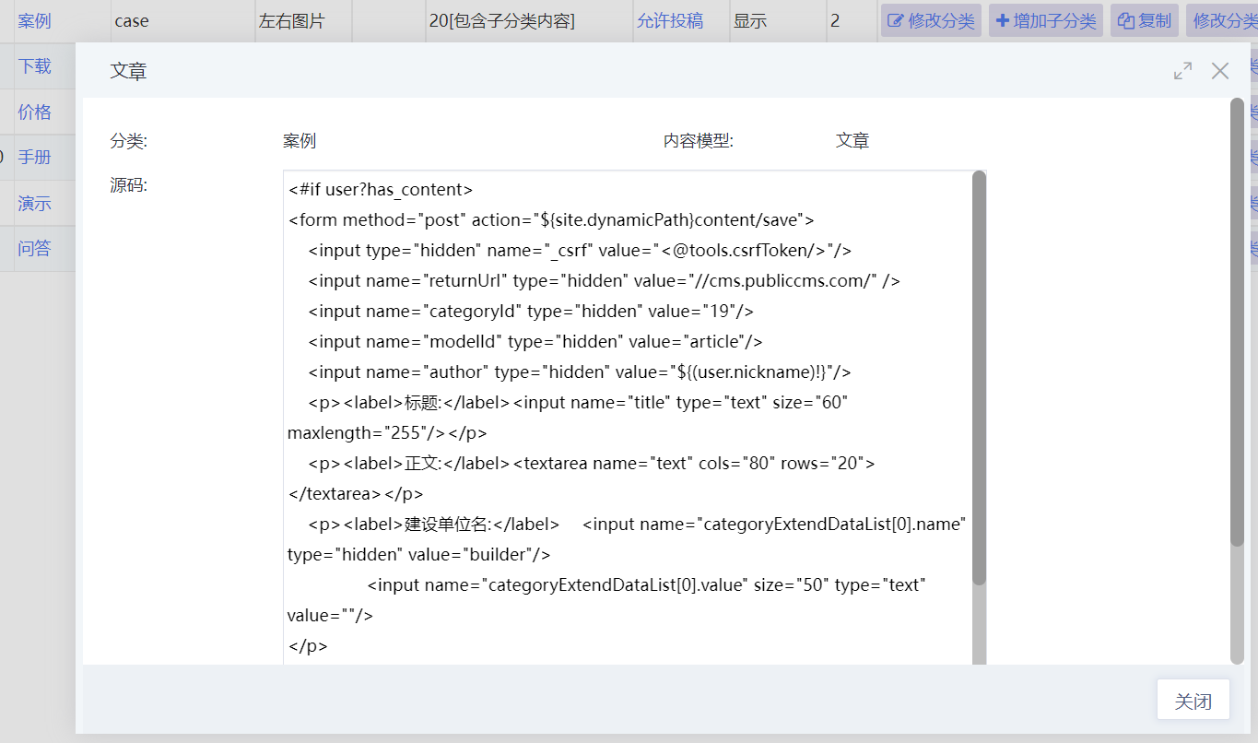
You can paste the contribution code to any dynamic template. You can select “log in necessary” to set up the metadata of the template . The title is required in the contribution field. Use js or css to control style and interaction.

Content page template
The content page template is usually used to display the articles entered in the background and other classified information. The Public CMS supports dynamic display of content and staticize the content for one or more copies.

Dynamic access
In dynamic display, you need pass at least one content id parameter to the template to facilitate the use of directives in the template to get content-related data.
Set up to allow dynamic access in the background template metadata and set acceptable parameters. The category id should be passed to this parameter when the template is used in other templates.

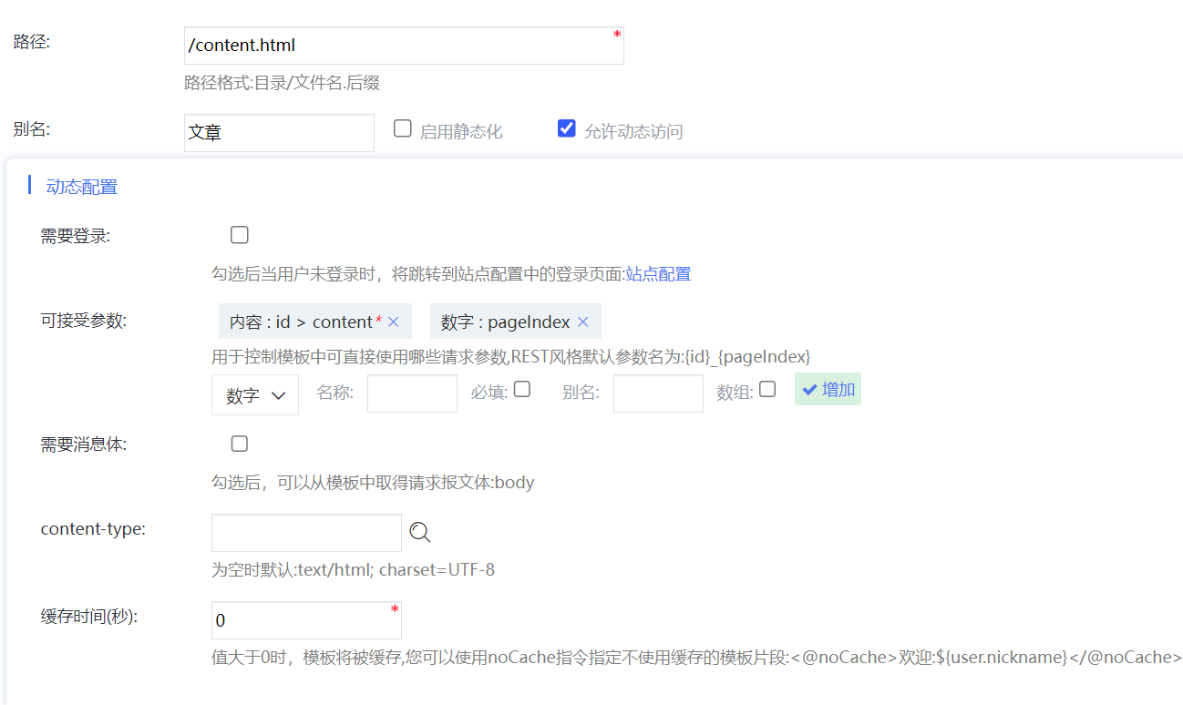
Select the conresponding template in category and clear up the static template . Set the access path of the content page to the template path above. The parameter name is the acceptable parameter name above, and the value is ${content.id}.
The corresponding dynamic address to the template metadata confugration above is: content.html?id=${content.id}
or REST style address：content/${content.id}

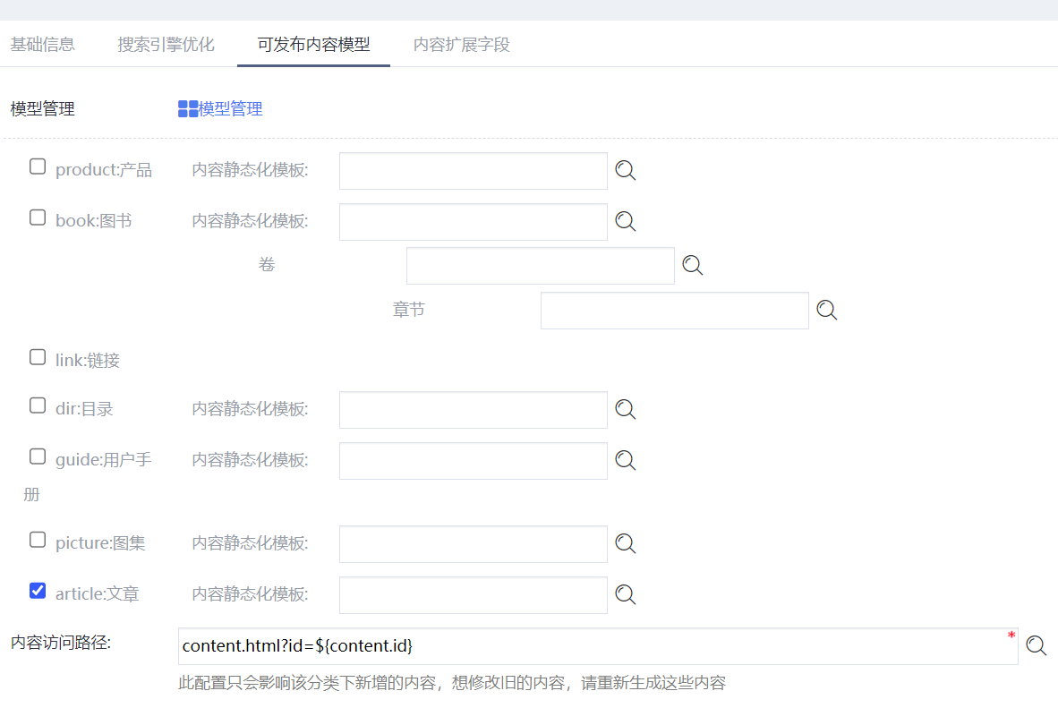

Static
You don’t need to select “enable static” for content template metadata setting.

To staticize content page template, you need to set up publishable content model for category management in the background(Select “Show Advanced Options” next to “Save” button in the upper right corner to display the TAB page) , select static template for the publishable content model and configurate static style content page accessing path. The configurated template will be used to generate static page for content when the contents are saved, the contents are generated in batches, and the task plan is generated.
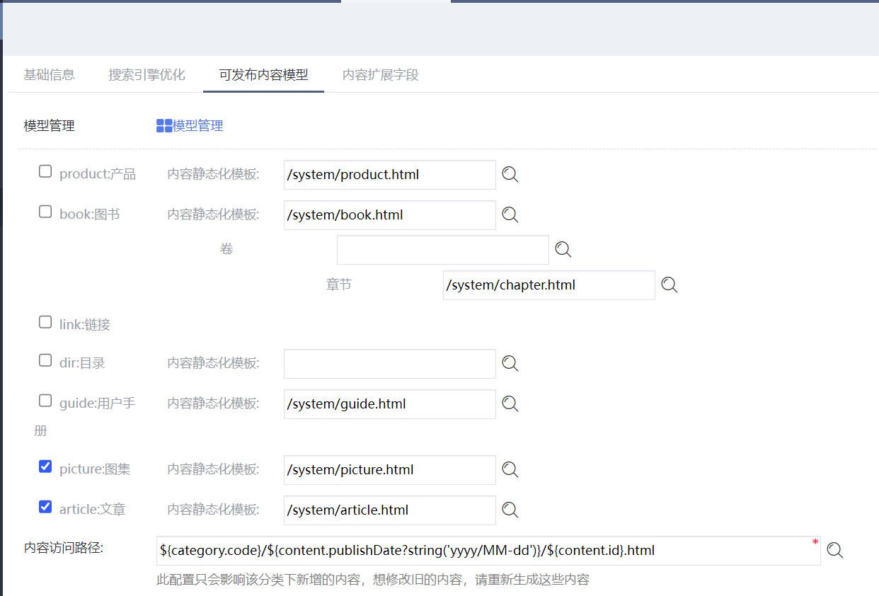

Numbers of clicks update
Content clicks are usually updated in the content page using js.
<article>
<p>Views:<em>loading...</em></p>
</article>
<script>
$.getJSON('${site.dynamicPath!}api/contentClick?id=${content.id}', function(data){
$('article p em').text(data.clicks);
});
</script>

Rich text content style control
Editor can modify content style and picture size in content text. To prevent the layout adjustments in the editor from affecting the overall style of the site, you can refer to the following style controls.
<style>
.clearfix::after{display: block;clear: both;content: "";}
article #content img,article #content table {max-width:100%;}
article #content{width:100%;overflow: auto;}
</style>
<article>
<div id="content" class="clearfix">${(text?no_esc)!}</div>
</article>
<script src="${site.dynamicPath}resource/plugins/ueditor/ueditor.parse.min.js"></script>
<script>
uParse('#content',{rootPath: '${site.dynamicPath}resource/ueditor/'});
</script>

Extention fields
You can use content model and category to manage content extension field.
Modify or add content model in the Setup->Content model management.
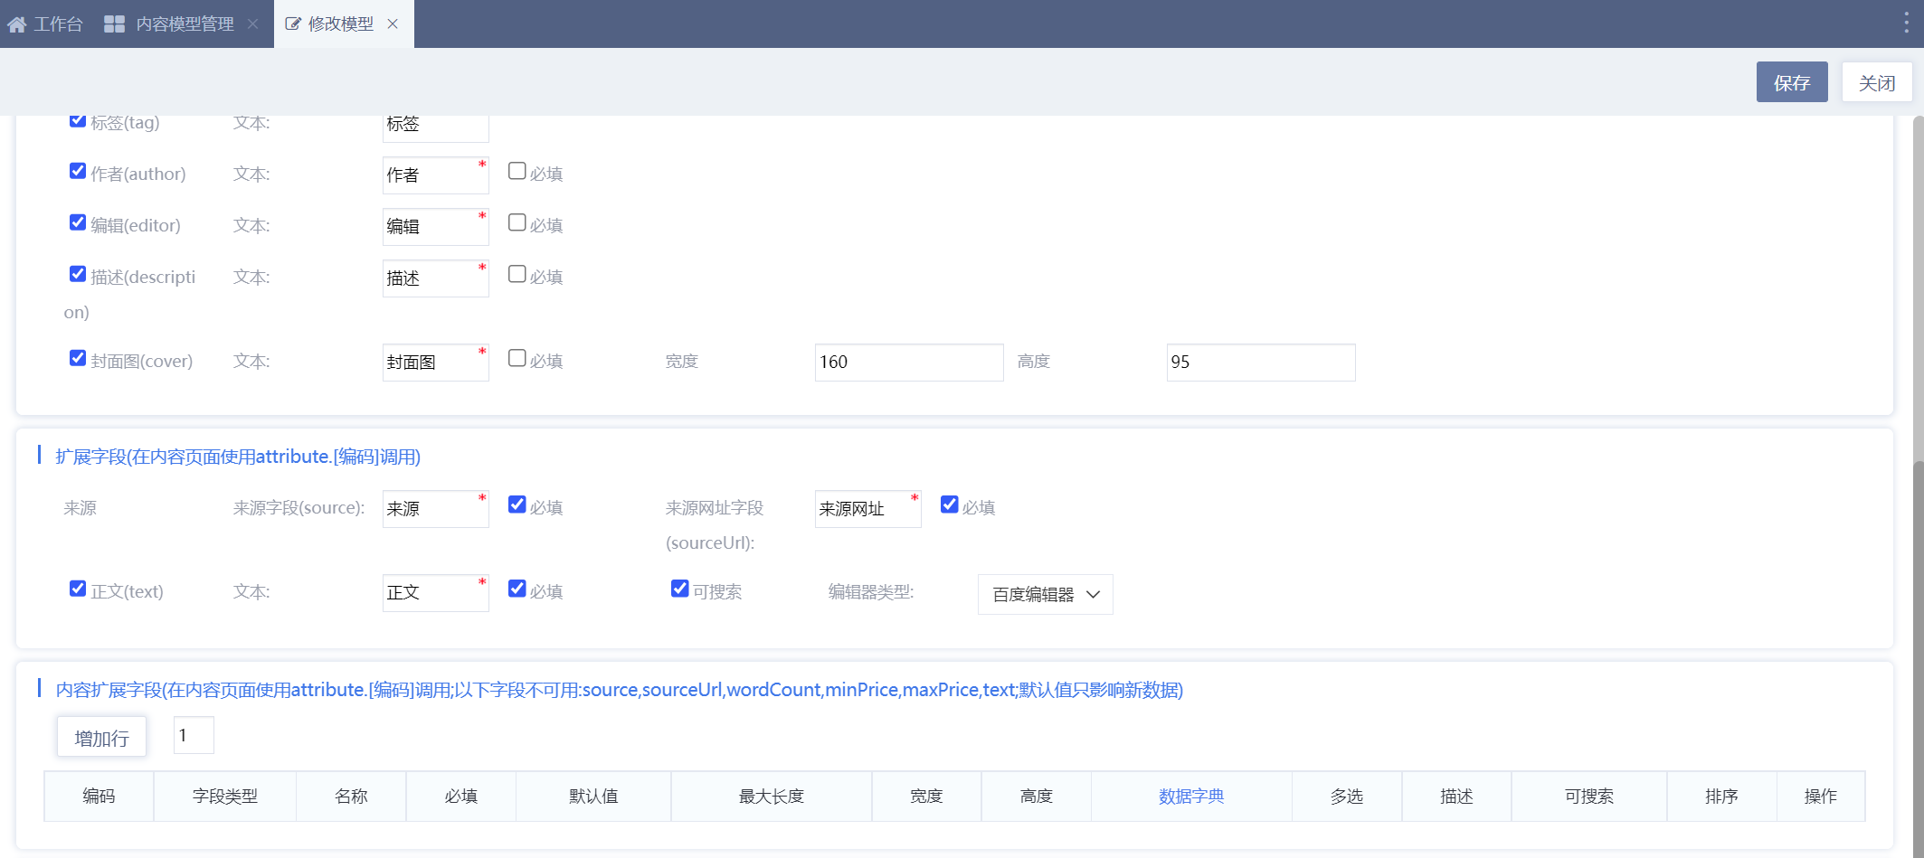
Or modify or add category in Content->Category management( Switch to the publishable Content Model management TAB and check the content that is allowed to be published).
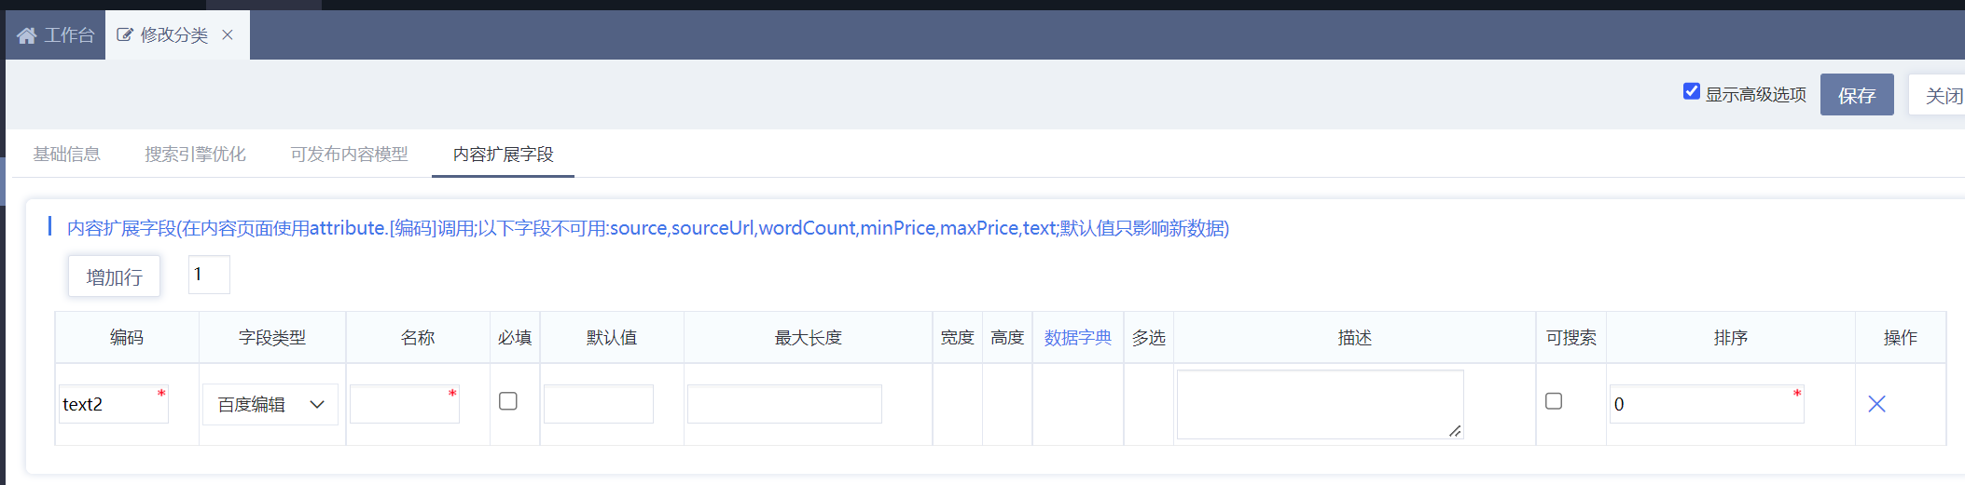
Edit content template, and use extension field. All extended field types are stored in string format.
<#assign attribute=getContentAttribute(content.id)/> <#-- On the static content page, you can use attribute objects. On the dynamic content page, you need to obtain attribute objects -->
${(attribute.text2?no_esc)!} <#-- To output an editor field, use no_esc to declare no safe escape -->${getUrl(attribute.file)!} <#-- Attachments need to be converted to absolute paths using getUrl -->

You can maintain those extented fields in corresponding content maintainance page.

Task plan script
Task plan script is used in Public CMS task plan and data operations are performed under ordinary directives and task plan special directives and is scheduled by a task schedule, such as a periodic generation in a static site.
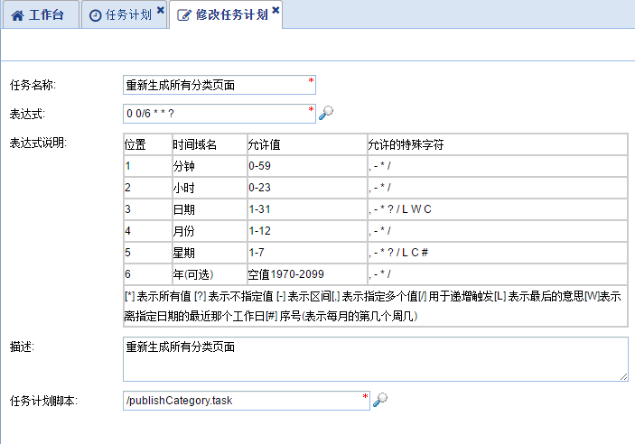

Template Fragements
Template fragments are the freemarker template engine's template reuse solution. There are two ways to use template fragments: include and import.
Template fragment inclusion is the extraction of a template statement into a separate file that can be included by different templates. You can reuse a portion of the template, reducing the total amount of code and the amount of work required to modify the repetitive content. The variables in the template context above can be used directly in the included template fragment.
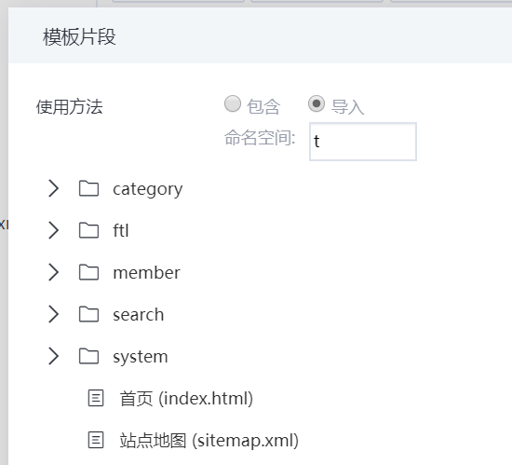
When you import a template, you need to name it a namespace, and when you use a variable or function or directive definition in the template, you need to take the namespace with you. The import method can effectively avoid contamination of context variable names.

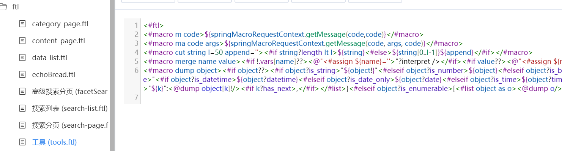
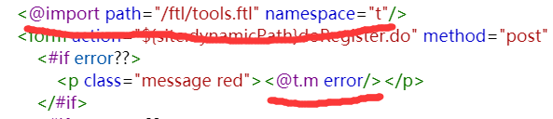
More files and documents about namespaces:
http://www.kerneler.com/freemarker2.3.23/dgui_misc_namespace.html

Page Fragements
Page fragments are introduced by Public CMS in product design. Each page fragment is a complete page, which is parsed into text (such as html) and then embedded in the page that references it. When it renders, you can't get the variable of the template that references it. After SSI is enabled, page fragments can be generated periodically through the task plan. The page fragment reference in the template will print only one ssi directive, which will be dynamically included by services such as nginx when requesting html. This can greatly improve the speed of template rendering.
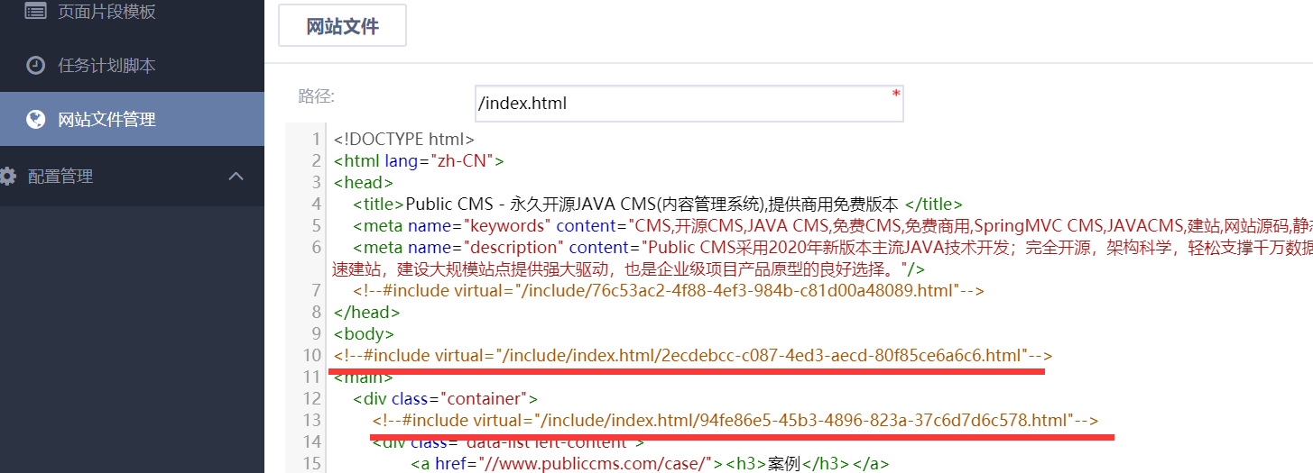

Recommended bits
Page fragments can also be bound to an extensible data list by setting the number of valid data in the metadata. Page fragments bound with data are generally referred to as recommendation bits, such as focus map, friendship link, editing recommended articles, etc., which can be realized by using recommendation bits. Developers can develop less background management functions, because fragmented data display and maintenance can be realized by adding page fragments in the background .

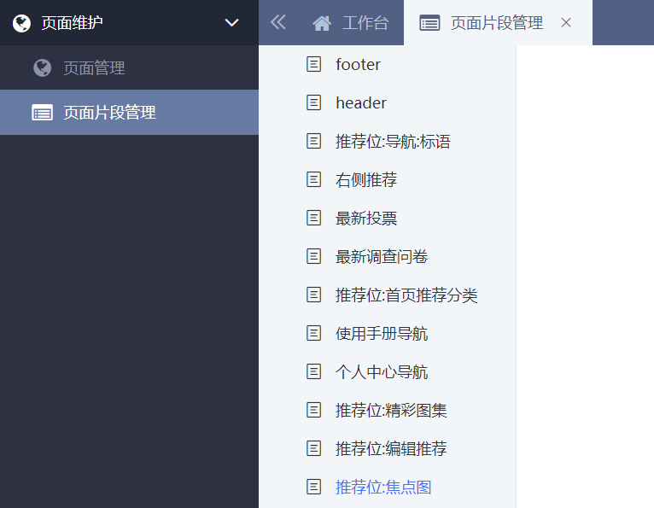
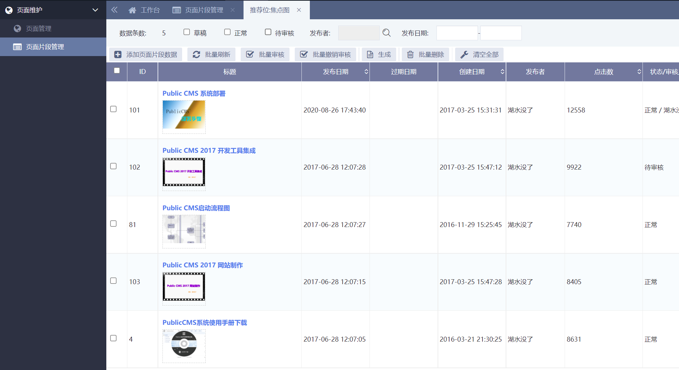

Extended field
You can manage the page fragment metadata extended fields in editing page fragment metadata under File-> Page fragment template .
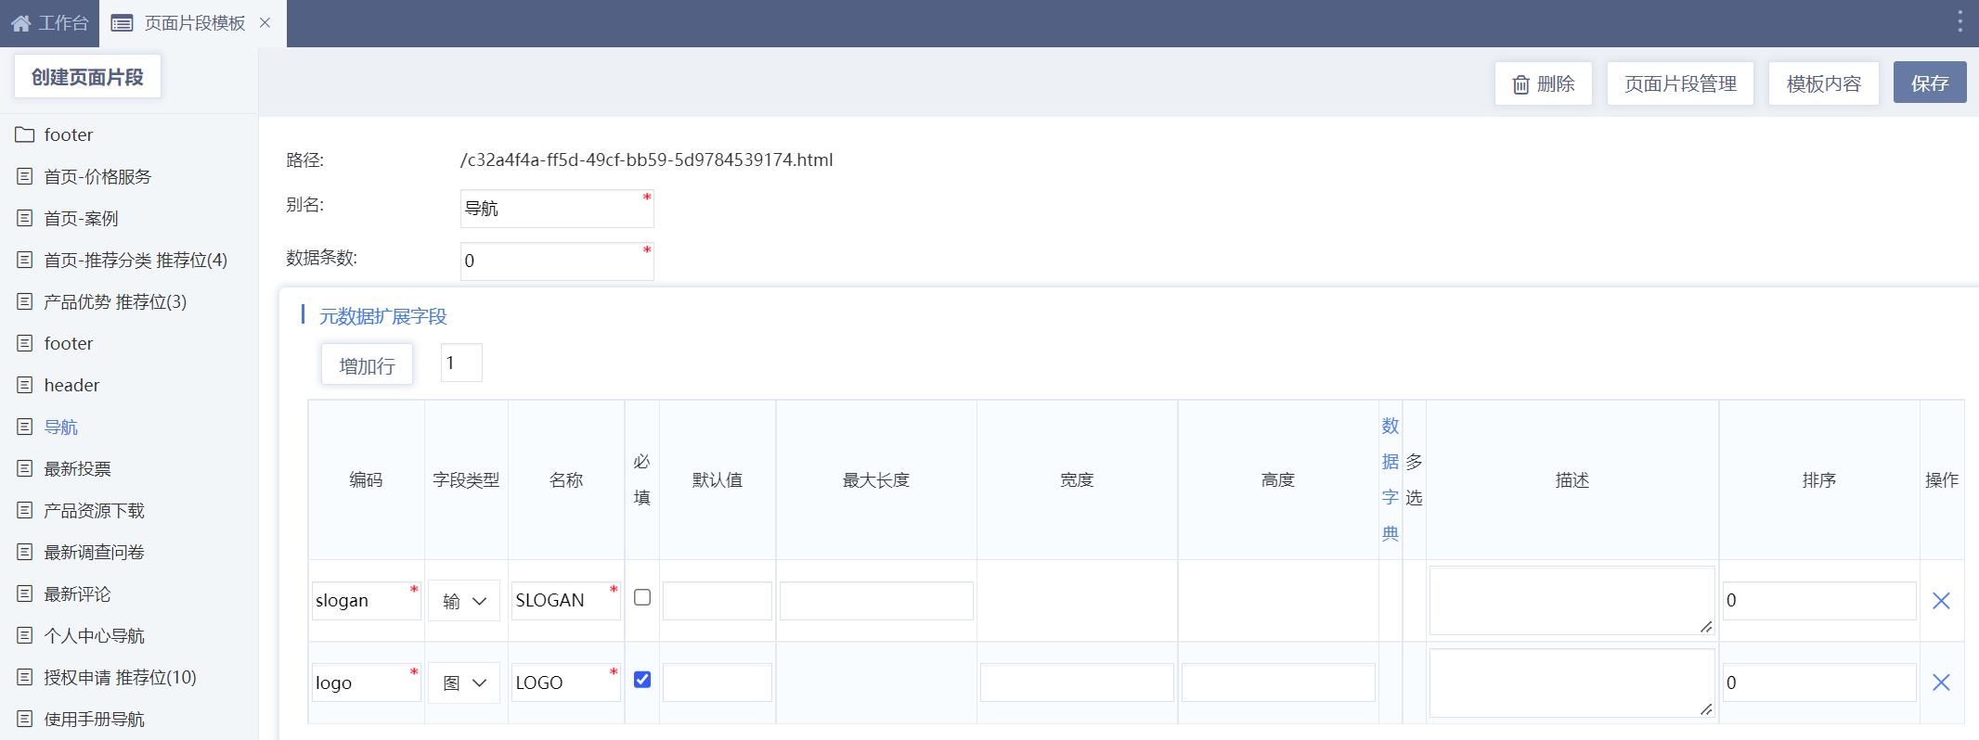
Click the template properties ( in the Template Help) -> The extension fields to edit the page fragment template,, and modify the code logic to use these extension fields in an appropriate manner. All extended field types are stored in string format.
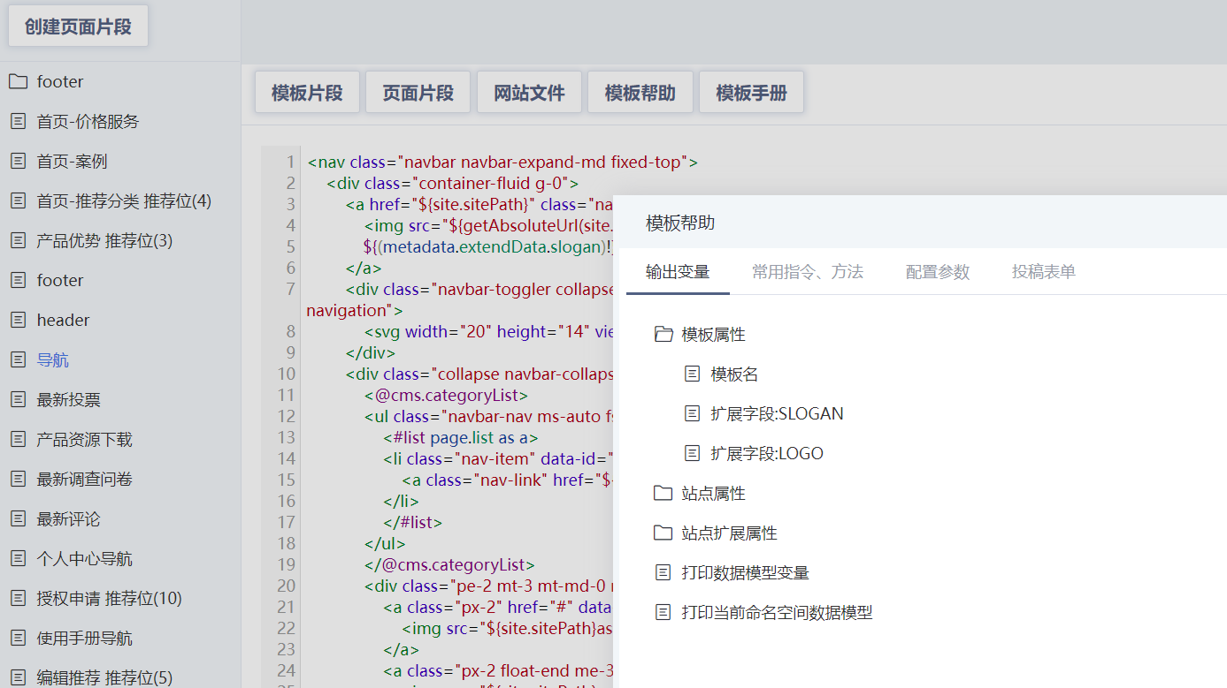
For example: extended field encoding slogin
${(metadata.extendData.slogan)!}

Select this Page fragment in Page ->Page fragment management for maintenance .
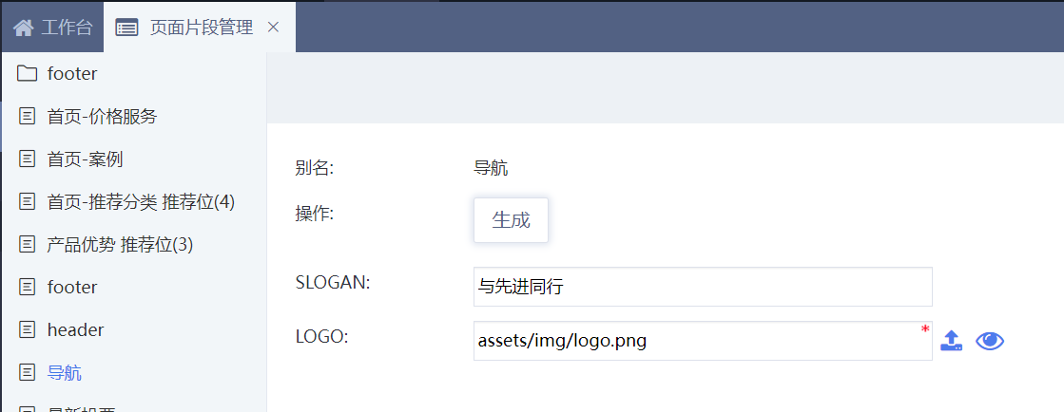

Extended Field for Recommended Bits
When editing page fragment metadate in File -> Page fragment template, you can manage the extended field for recommended bits ( This parameter is displayed only when the number of data bars is greater than 0).
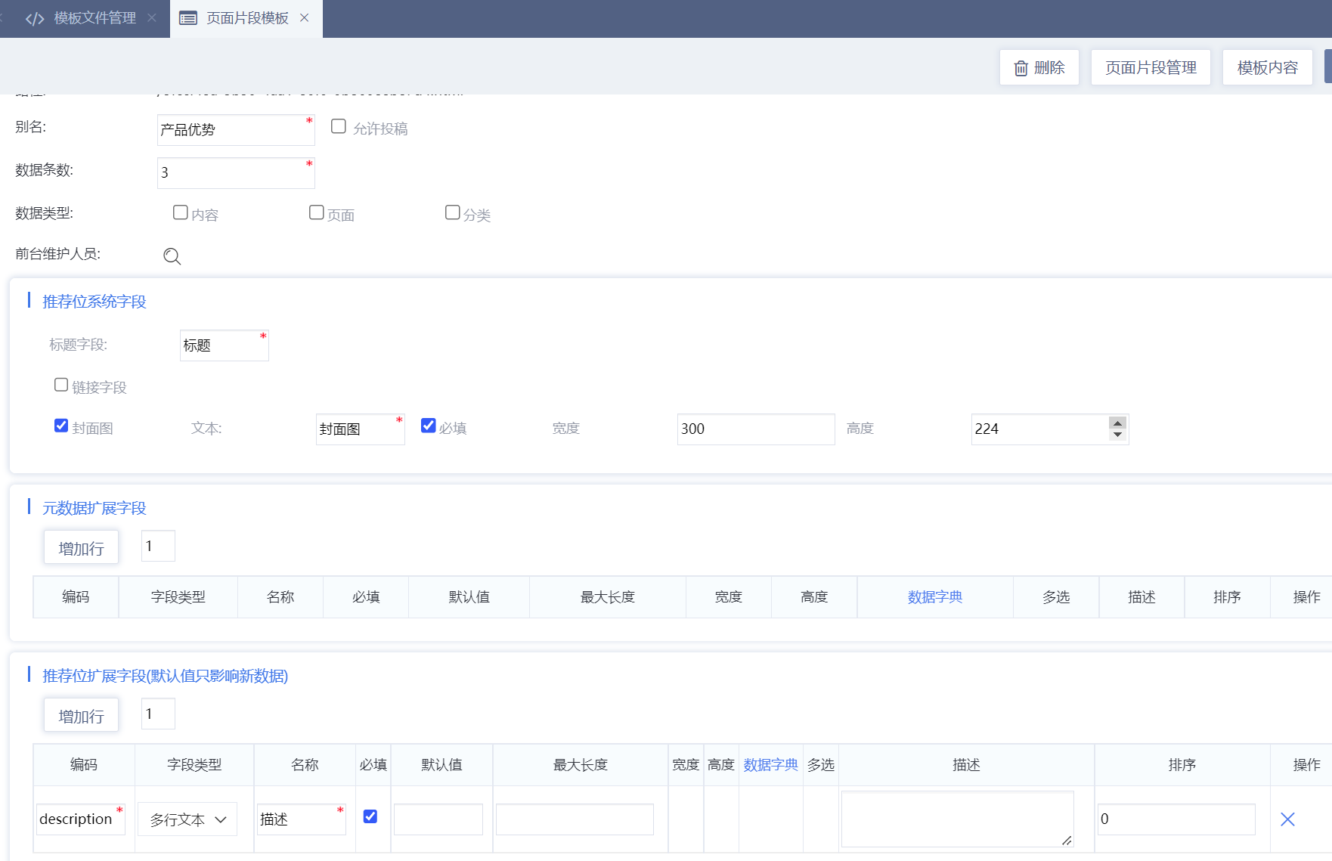
Edit page fragment template, and use the extended fields, and all extended field types are stored in sting format.
<#list page.list as a>
<#assign attribute=getPlaceAttribute(a.id)/>
${(attribute.description)!}
${getUrl(attribute.file)!} <#-- Attachments need to be converted to absolute paths using getUrl -->
</#list>
Select this page fragment in Page->Page fragment management to modify the recommended bit data.
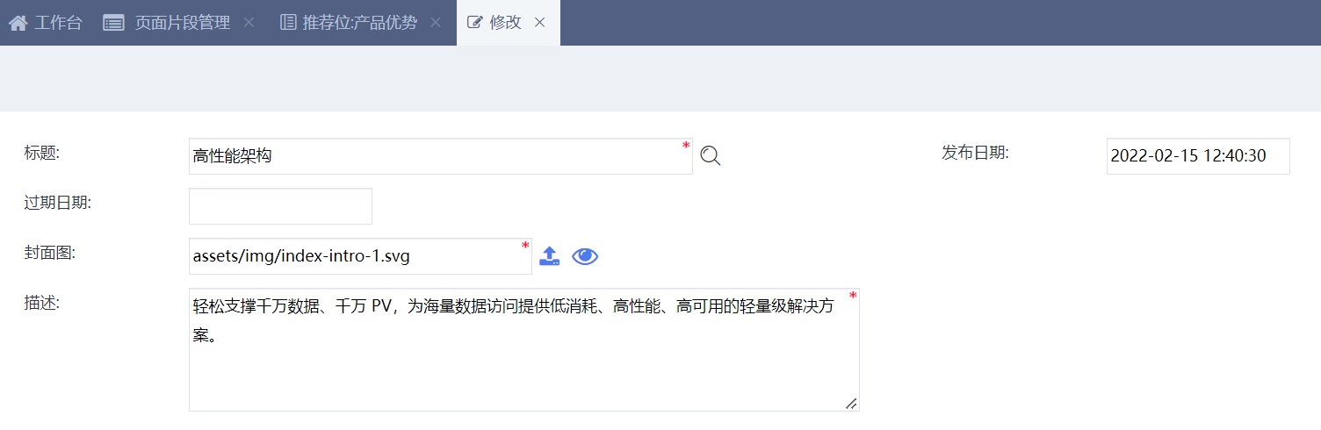

Recommended bit contribution
When editing page fragment template metadate in File-> Page fragment template, you can manage the recommended bit contribution.
Check to allow contributions, and decide whether to check to allow anonymous contributions according to the actual needs . You can also set the front desk maintenance personnel, and these users don’t need to log in the background management of the contribution data for audit, revocation audit, delete and other management operations.
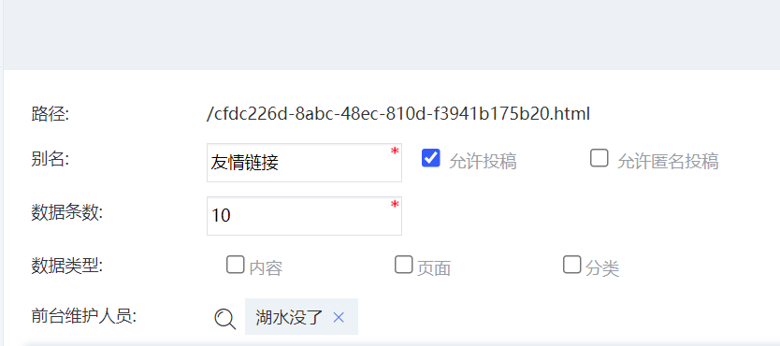
Obtain contribution code and front desk maintenance function code in Template help->Contribution form.
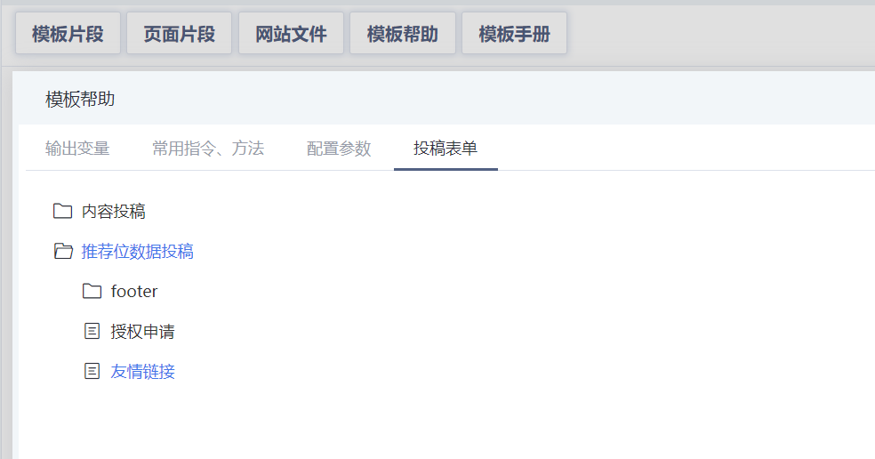
Paste it into any template. If anonymous contributions are not allowed, you need to use dynamic template for contributions, and this dynamic template can be set you need to log in to set the metadata, the title of the contribution field is required, and use js or css for style and interactive control with the form.
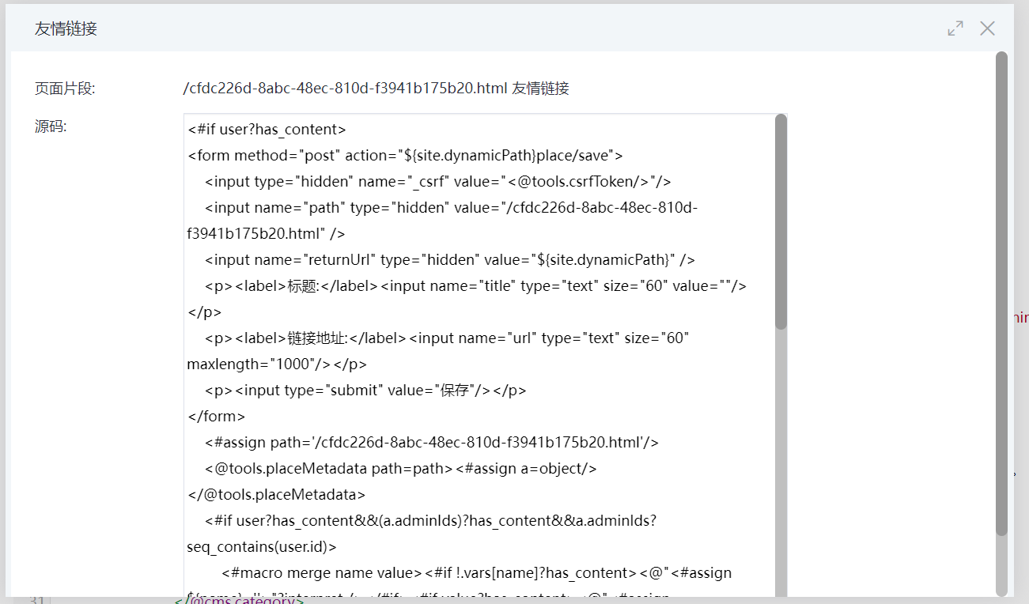

Template language

Profile/Overview
PublicCMS uses the FreeMarker template engine to render the templates, and this template has perfect data processing, logical judgment function. It uses a simple, proprietary language. The PublicCMS program stores and queries data, and then the template displays the prepared data.
PublicCMS extends the data instructions and functions of FreeMarker.

Template Syntax
Template syntax is the part of a template that is parsed by the template engine. Identifying template syntax helps you understand the operating mechanism and working principle of PublicCMS.
A template (= FTL program) is a mix of the following sections:
- Text: Text that will be printed to the output as is.
- Interpolation: These sections will be replaced with a calculated value in the output. Interpolations are delimited by ${ and } (or with #{ and }, but that shouldn't be used anymore; see more here).
- FTL tags: FTL tags are a bit similar to HTML tags, but they are instructions to FreeMarker and will not be printed to the output.
- Comments: Comments are similar to HTML comments, but they are delimited by <#-- and -->. Comments will be ignored by FreeMarker, and will not be written to the output.
Let's see a concrete template. I have marked the template's components with colors: text, interpolation, FTL tag, comment. With the [BR]-s I intend to visualize the line breaks.
<html>[BR]
<head>[BR]
<title>Welcome!</title>[BR]
</head>[BR]
<body>[BR]
<#-- Greet the user with his/her name -->[BR]
<h1>Welcome ${user}!</h1>[BR]
<p>We have these animals:[BR]
<ul>[BR]
<#list animals as animal>[BR]
<li>${animal.name} for ${animal.price} Euros[BR]
</#list>[BR]
</ul>[BR]
</body>[BR]
</html>

Data instruction extension
Getting data through custom instructions is the main way that Public CMS implements template customization, because directives are a special kind of data model in freemarker templates. Therefore, in addition to the import and include directives, the directives in the Public CMS template can be prefixed with "_" or the “package name. short instruction name” to distinguish from the data in the template. Also, the instructions in the template can be invoked by js , json interfaces ,or other systems.

There are four main types of instructions in the template:
- An instruction to get a single or multiple entitiy instructions based on the primary key
- An instruction to query a list based on criteria
- Task schedule specific directives: This class of directives can only be used in task schedule scripts
- Function instructions: This class of instructions is used to complete a specific function and can be used in any template
You can modify a template by using the template creation help provided by the background template editing function of the Public CMS, or by viewing the instruction function user manual for instructions on how to use instructions.

Entity Query Instruction
Query a single entity
<#assign id=1/>
<@_ Instruction name id= id >${object. attribute }</@_ Instruction name >
或
<@ package name. short instruction name id= id >${object. attribute }</@ package name. short instruction name >

Or Query multiple entities
<#assign ids=’1,2,3’/>
<@_ Instruction name ids= ids>${map[‘1’].id}</@_ Instruction name >
或
<@ package name. Instruction name ids= ids>${map[‘1’].id}</@ package name. Instruction name >

List query instruction
These instructions all have two parameters, pageIndex and count, which respectively represent the current page number and the number of items on each page. The query result is Page.

Query list data
<@_ Instruction name pageIndex=1 count=10>
<#list page.list as a>
${a? counter}:${a.id}<#if a?has_next>,</#if>
</#list>
</@_ Instruction name >
or
<@ package name. short instruction name pageIndex=1 count=10>
<#list page.list as a>
${a? counter}:${a.id}<#if a?has_next>,</#if>
</#list>
</@ package name. short instruction name >

page Attribute list
Properties | Type | Meaning
totalCount | int | Total data
pageSize | int | Number of articles per page
pageIndex | int | Current page number
list | List | Query the result entity list
totalPage | int | Total page count
firstResult | int | First serial number
firstPage | boolean | First page or not
lastPage | boolean | Last page or not
nextPage | int | Next page number
prePage | int | Last page number

Function Extension
Function extension is a lightweight form of freemarker extension . A function can accept multiple parameters but only have one output.
In Public CMS, relatively simple data acquisition and the processing of some variables are usually implemented by methods. You can use the template making help provided by the template editing function in Public CMS background to use the function. You can also check the instruction function manual for instructions on how to use them.
For example:
Get the content extension properties
<#assign attribute=getContentAttribute(id)/>

Macro definition
You can encapsulate a piece of template code as a macro definition for the purpose of reusing code or completing recursive calls.
For example:
<#macro bread category>
<#if category.parentId?has_content>
<@cms.category id=category.parentId>
<@bread object/>
<a href="${object.url!}" target="_blank">${object.name}</a> &gt;
</@cms.category>
</#if>
</#macro>
<@bread category/> <a href="${(category.url)!}" target="_blank">${(category.name)!}</a>
Output effect :Introduction > Questions
More documents：http://www.kerneler.com/freemarker2.3.23/dgui_misc_userdefdir.html

Aliases and scopes
When the variable output in the instruction is the same as the variable above, the variable name inside the instruction represents the variable output by the instruction, and the variable name is reset to the value represented by the variable above at the end of the instruction.
In order to maintain uniformity, most output variables in the system are set to object,page,list,result and other variable names with no clear meaning. When calling the instruction, you can specify the alias of these variables, and these variables and variable aliases will be reclaimed at the end of the instruction.
To continue using a variable after the directive ends, define a new variable name with assign.
For example:
<#assign id=1/>
<@cms.content id=id;content>${content.title}</@cms.content > The following output will indicate that content does not exist ${content.title}
<@cms.content id=id><#assign content=object/>${content.title}</@cms.content > The following output prints the title of the content ${content. title }

Template manual
The FreeMarker manual provides a systematic introduction to template logic and common data processing rules. Reading through the manual will allow you to quickly find the help you need in your template writing process.
Common template manual help index：
Template tutorial：
Instruction：http://www.kerneler.com/freemarker2.3.23/dgui_template_directives.html
Expression：http://www.kerneler.com/freemarker2.3.23/dgui_template_exp.html
interpolation：http://www.kerneler.com/freemarker2.3.23/dgui_template_valueinsertion.html
Reserved keyword：http://www.kerneler.com/freemarker2.3.23/ref_reservednames.html
Define variables in the template：http://www.kerneler.com/freemarker2.3.23/dgui_misc_var.html
Use help：
Built-in function reference http://www.kerneler.com/freemarker2.3.23/ref_builtins.html
Instruction reference http://www.kerneler.com/freemarker2.3.23/ref_directives.html
Special variable：http://www.kerneler.com/freemarker2.3.23/ref_specvar.html

Template data
Use <#list .data_model?keys as k>${k}</#list> in template to output the name of the data model variable for the current template , you can see which variables are directly available in the current template.
In dynamic templates you might get the following information:
site,RequestParameters,springMacroRequestContext,Request,JspTaglibs,org.springframework.validation.BindingResult.metadata,include,Session,Application,base,import,user,metadata
In ststic templates you might get the following information:
site,import,url,include,metadata
Import,include are the built-in import and include directives of Public CMS; RequestParameters, springMacroRequestContext, Request, JspTaglibs, org.springframework.validation.BindingResult.metadata, Session, Application are objects injected into the dynamic template by springmvc framework. Public CMS provides you with many convenient solutions. When it cannot meet your needs, you can use the objects provided by the framework to complete more complex business implementation.

Common Data
- site: site
Property | Type | Name
id | int | Site ID
name | string | Site name
useStatic | boolean | Enable statics
sitePath | string | Static site access address
useSsi | boolean | Enable server-side inclusion
dynamicPath | string | Dynamic site access address
disabled | boolean | Disabled
- siteAttribute: Site extension attribute
You can modify the configuration of siteAttribute to perform extended field management in Setup ->site configuration management. You can modify the configuration data of siteAttribute in System -> site configuration .
For example, extend field encoding searchPath
${(siteAttribute.searchPath)!}

Common Data of Web Templates
- metadata: metadate
Property | Type | Name | Example
alias | string | Template name
publishPath | string | Publishing path
useDynamic | boolean | Dynamic access or not
needLogin | boolean | Whether to log in
acceptParamters | string | List of acceptable parameters
cacheTime | int | Cache time
extendList | list | Extended field list
extendDataList | list | Extended data list
extendData | map | Extended data hash table | ${metadata.extendData. extended field name }
- lang
The current language code, effective when the site has multilingual support enabled

Static template common data
url: Static path of template.
When you static content and classification, because static file has not been created, you will get null value when reading the url property in the template. If you want to display the address of current page, you need to use ${url}.

Static classification Template Data
category: category entity
attribute: category extend
pageIndex: current page number

Static content Template Data
content: content entity
category: category entity
attribute: content extension
page: pagination
text: text

Recommended bit data
page: Paged data

Dynamic template common data
- base: the root path of the current dynamic site
For example :
<a href=”${base}”> Return to home page </a>

- user: current login user
Property | Type | Name | Example
id | int | User ID
siteId | int | Site ID
name | string | User Name
nickname | string | Nick name | <#if user??> hello，${user.nickname}<#else>not logged in </#if>
deptId | int | Department ID
roles | string | Role ID
email | string | Email address
emailChecked | boolean | The email address has been verified
superuserAccess | boolean | Administrator rights
disabled | boolean | Disabled
lastLoginDate | date | Last login date
lastLoginIp | string | Last login IP address
loginCount | int | Number of logins
registeredDate | date | Date of registration

Dynamic Template Parameter Data
In the Public CMS background, you can set the parameters that the template can receive. The request parameters accepted by “http” when requesting a template are placed in the template's data model, which you can use directly using the parameter names.
For example:
We set “id” as an acceptable parameter in one of the template metadata.

We can use ${id} to output the value of the parameter in template. If this ”id” is the content ID, we can use <@_content id=id>${object.title}</@_content> to get the corresponding content for the id and output the title of the content.

Site Configuration Data
Under Setup -> Site configuration management, you can manage the extend field of system configuration items, add or modify configurations.
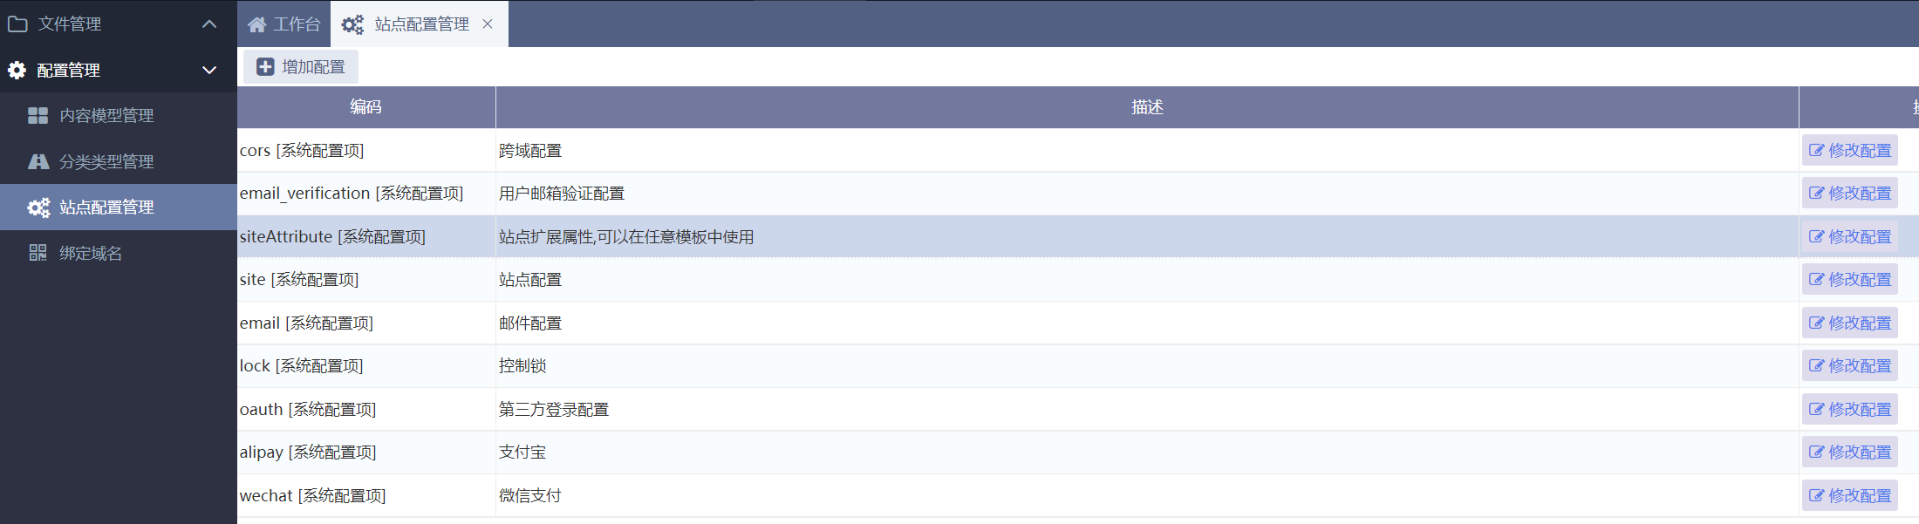

On the Template Edit page, click to use these site configure properties under Template Help.
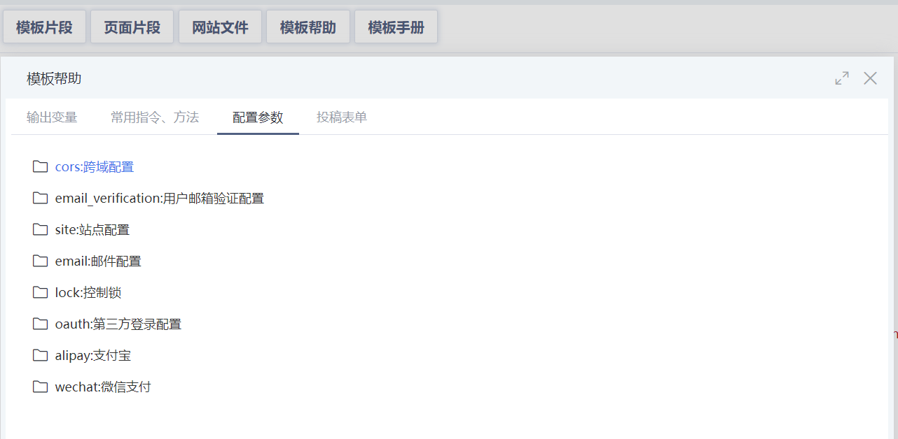
Under System->Site Configuration, you can maintain the extension fields of system configuration and user-defined configuration extension fields.
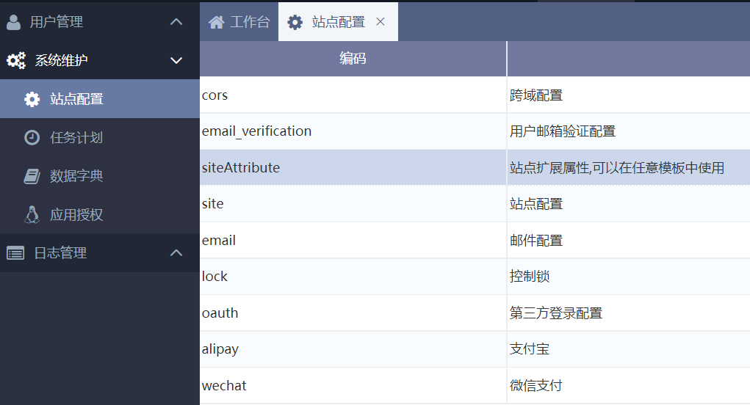

Multiple sites and multiple domain names
Each set of PublicCMS services can support simultaneous access to more than 30,000 sites. Each site can have multiple domain names

Multiple sites
Each site can not be affacted by another, and users, templates and files are independent.

Site management
PublicCMS distinguishs different sites by site configuration and domain name information. If there isn’t corresponding domain name ,the corresponding site of “cms.defaultSiteId” in the configuration file” cms.properties” will be visited instead. So do not delete the site ,otherwise your visiting will be error .
The administrative rights for the multiple sites management are based on the site corresponding to “cms.masterSiteIds” in “cms.properties”. There should be at least one site that has site management.

Distinguishing Sites
If you can not identify which site you are accessing when managing multiple sites , it may misunderstanding and human error may occur. The site you are visiting can be identified by the title of the background login page or the site name above the username entry box. If the actual visit does not meet expectations, you can adjust the “background site -> site Maintenance -> Domain name management” to adjust the corresponding relations between domain names and sites.
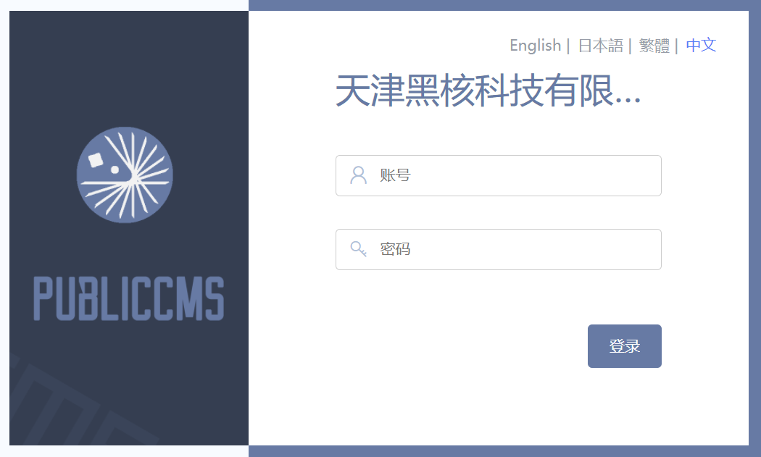

Creating new site
At a site with site administration rights，click “Site->site management->add site”. The domain name should be a domain name or ip that can access the server where the PublicCMS resides. Fill in the dynamic site address, static site address based on the actual situation.
After saving the above steps, enter the dynamic address of the new site in the browser. The access to the new site should be 404, because the new site has nothing. Add” /admin/” to the dynamic address to visit the background, using the user name and password of the new site to log in.
For example：
- when we are developing locally , start the project and visit http://localhost:8080/ to access the project's default site, and access to the background of http://localhost:8080/admin/ access to the background.
- Click the manu Site->site management->add site, fill in the information and save. The domain name could be” localhost,127.0.0.1,dev.publiccms.com” or its subdomain and ip. Here let’s take’ site2.dev.publiccms.com” for example.
- Visite”http://site2.dev.publiccms.com/admin/”，you can see the new site background, and you are free to modify and customize the new site.
Cms provides a quick configuration approach. The defaut static configuration button and default dynamic configuration can automatically generate site configuration according to the domain name of the current background you are accessing.
Before creating a new site, access the background using the expected domain name of the new site, click defaut configuration “ http://site2.dev.publiccms.com:8080/ admin/”.

Child site
The child site will share the content model and data dictionary of the parent site
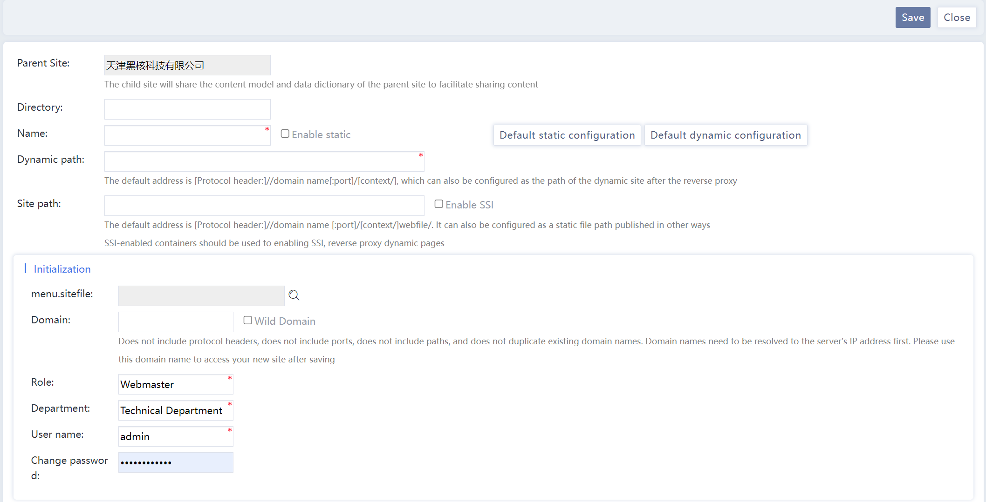
When the site group option is selected in the primary site domain name, the site directory of the subsite is valid. The access path of all subsites is the parent site path + subsite directory
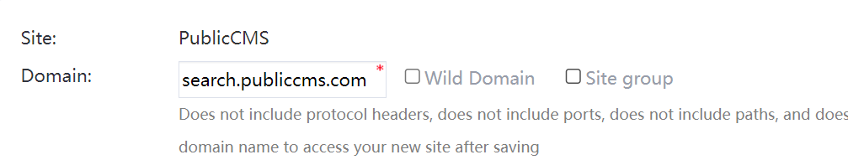
In this case, parentSite can be used to obtain information about the parent site in all sub-site templates, and all api interfaces should also be specified: ${site.dynamicPath}api_path?currentSiteId=${site.id}&otherParameters=values

Multiple domain names
One site can have several domain names, and each domain name can configure different template root directory.

Domain name management
In Site->site management, click the domain name list, you can view the domain name used by the current site and the corresponding template root directory.
For example:
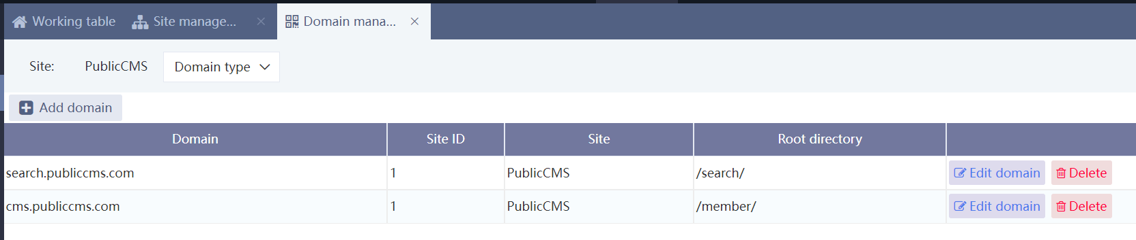
Accessing PublicCMS through “search.publiccms.com”, you are access the template under the search directory; Accessing PublicCMS through “cms.publiccms.com”, you are access the template under the member directory;

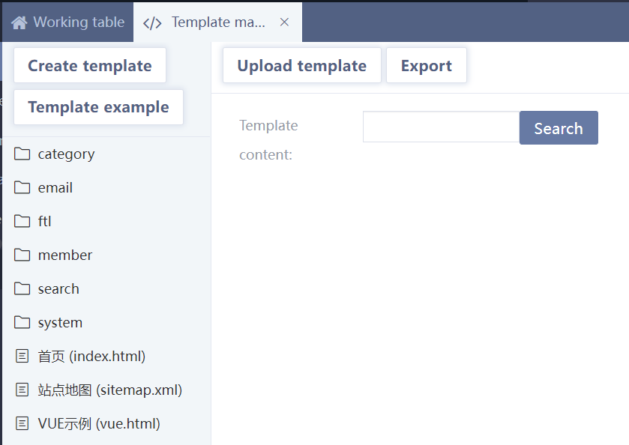

Possible Errors caused by binding a domain name to the root directory
Suppose the dynamic site address in the site peoperty ueses the domain names bound to the root directory, minor errors could be caused and should be adjusted according to the situation. Such errors can only happen while operating in the background and won’t affect the other functions, so the management people should pay attention.
For example
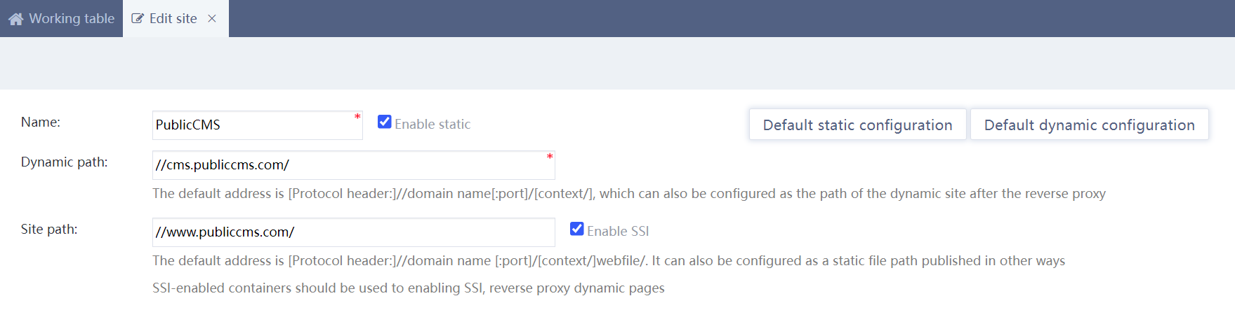
The dynamic page view button in page management points to the wrong url. 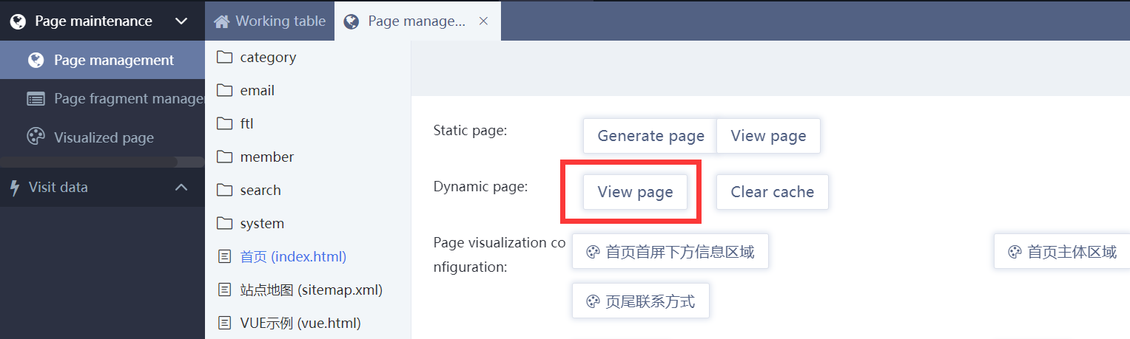
In the page fragment data selection, the dynamic page url here does not go to the page you selected. 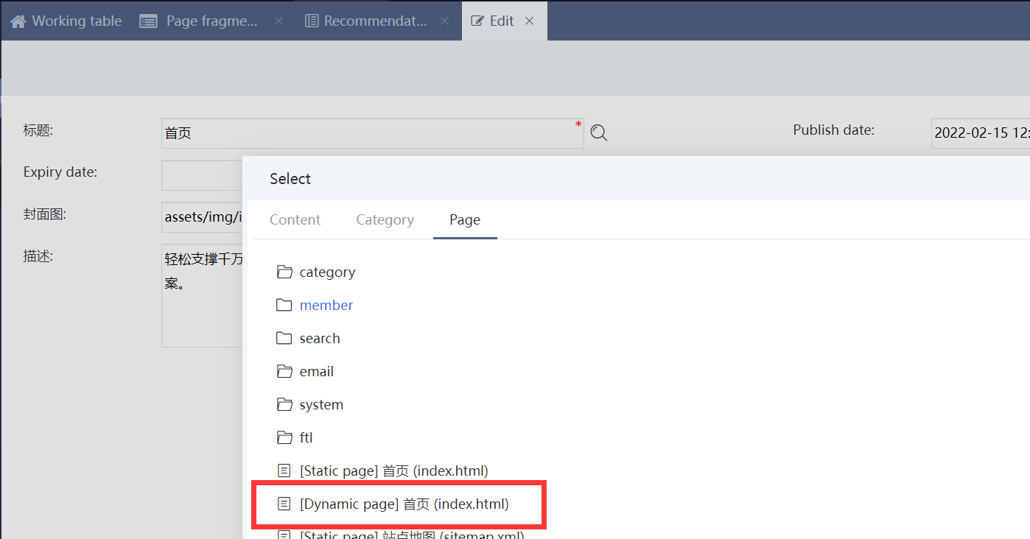

Feature Application

Template Examples
The template sample provides concise implementations of various requirement scenarios.
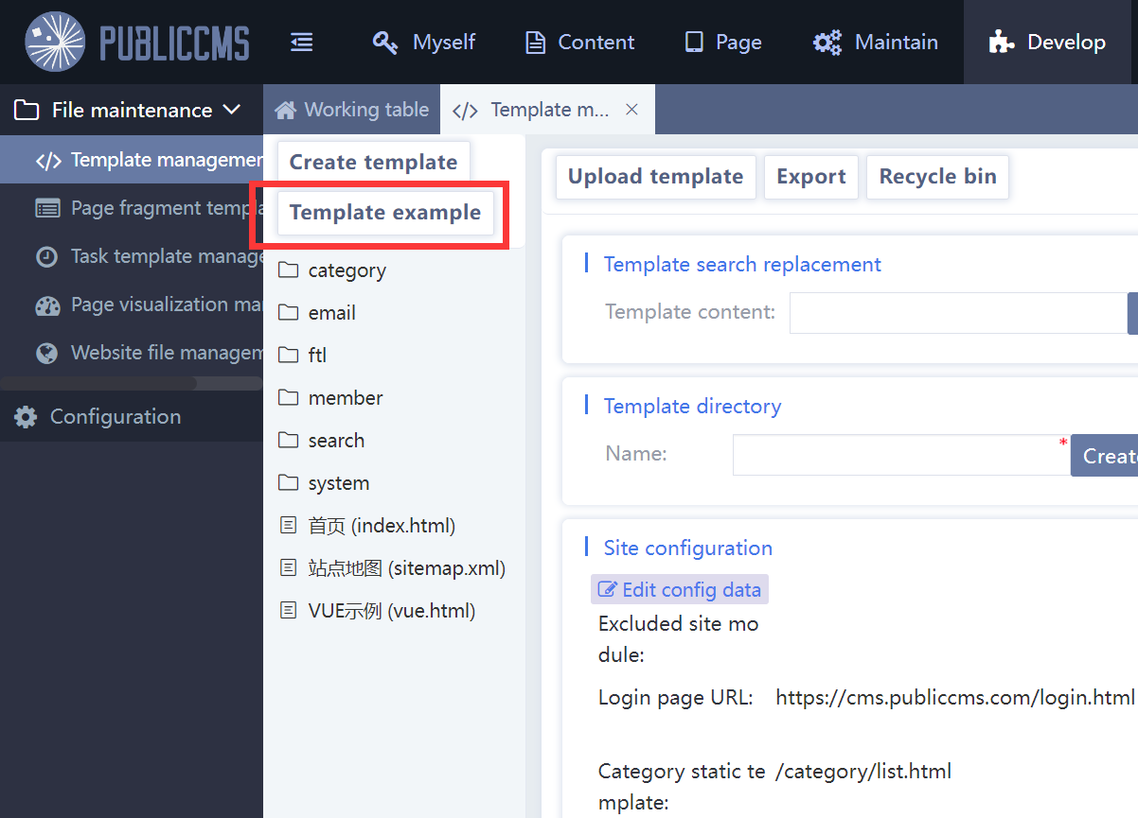
Expand the template example, and you can see examples of multi-language home page and switching, category page, content page, comment page, search page, login page, registration page, voting page, and sitemap.
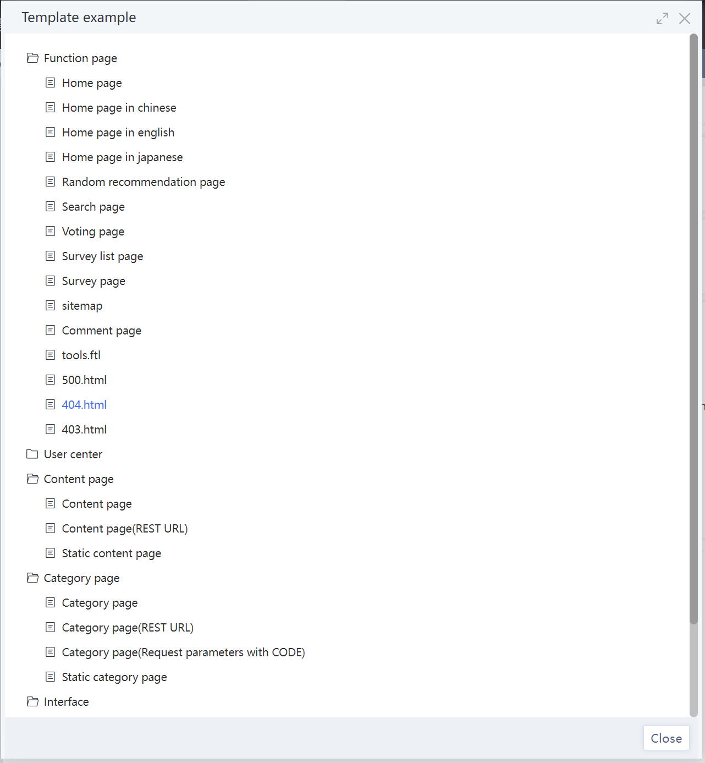

Click on these examples and then click the Save button to get a simple, directly accessible page (content page, category page dynamic templates require url parameters; Static templates need to be statically configured and published in the category before they can be accessed.

Template Help
Template help is an effective template editing aid provided by the template editing page, including output variables; Common instructions and methods; Configuration parameters; Submission form

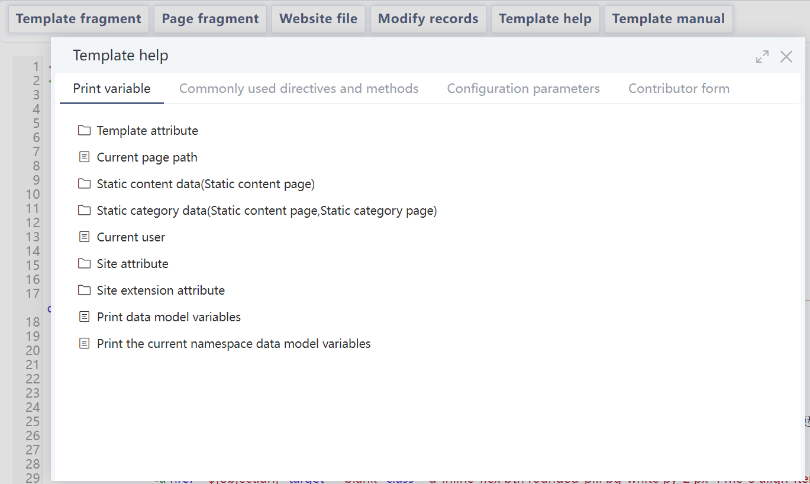
The output variables include: metadata extension parameter of the current template, static page data attribute, site attribute, global site extension attribute, etc
Common instructions and methods include: common entity query, list query, tool instruction, extended field query function, tool function, etc. Click these instructions or functions to get a simple example and common parameter usage description
The configuration parameters include: All site configuration items
The submission form includes: the content submission form of the category that allows the submission and the recommended bit page fragment data submission form that allows the submission

Searching and Replacing Templates in Batches
Enter the search content in the template content search box and click the "Search" button
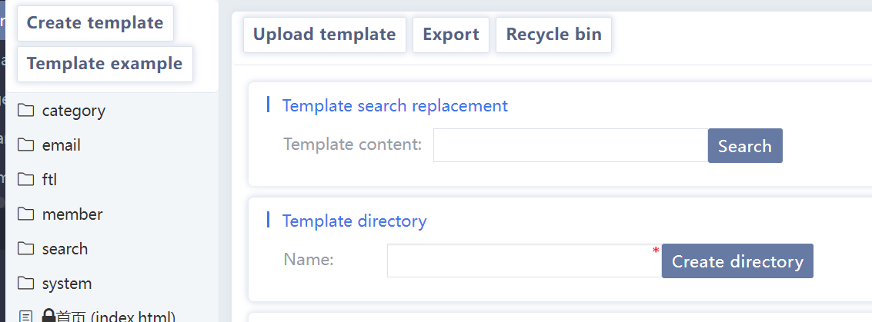
View the search results, modify the replacement content, uncheck the results that do not need to be replaced as required, and click the "Replace" button to batch replace the search results
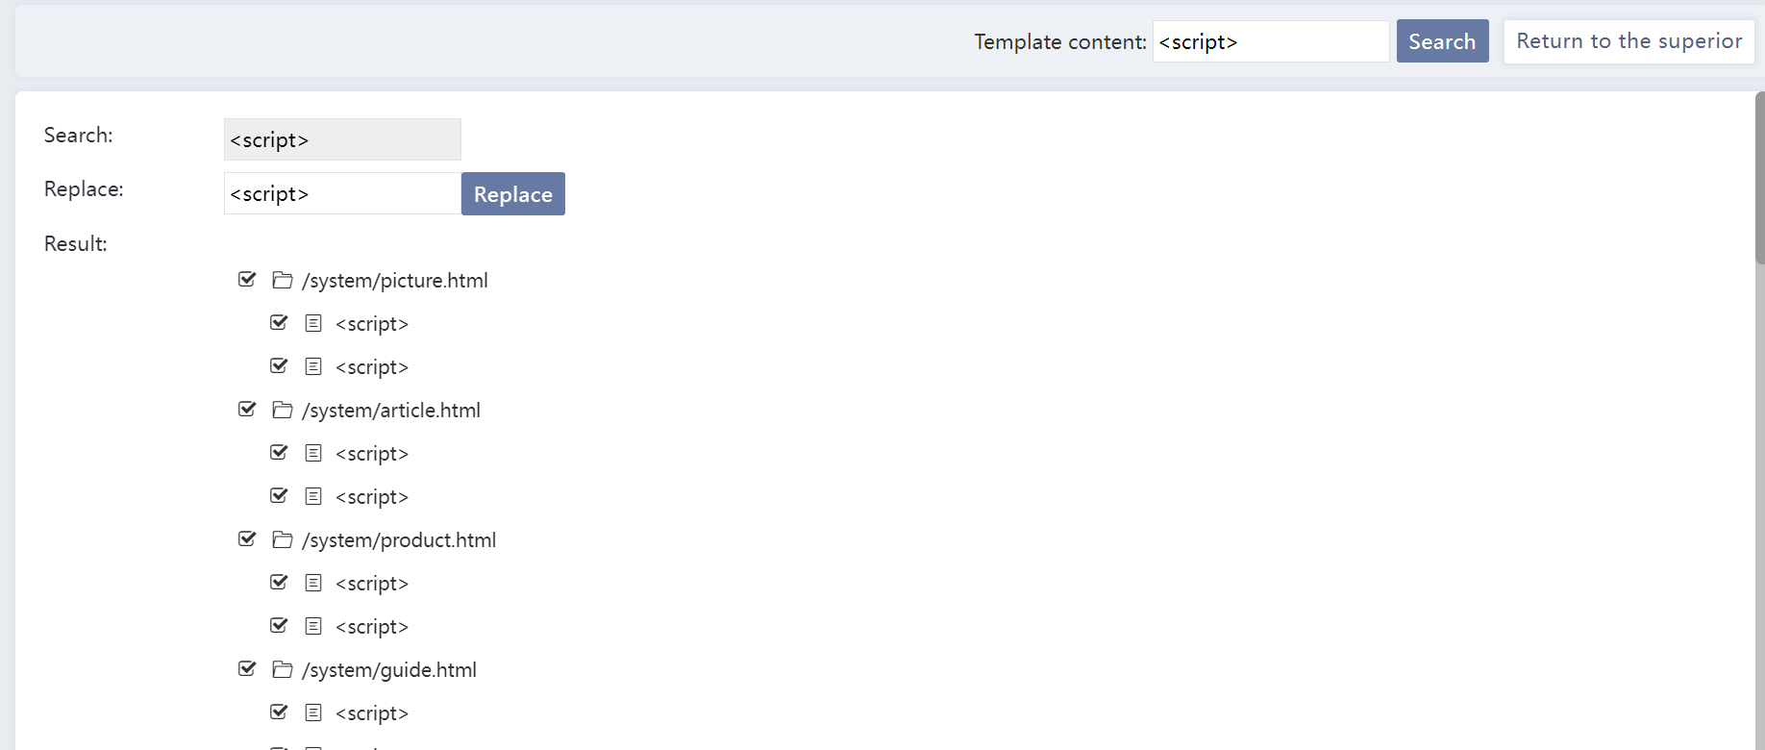
Batch search and replacement can improve the template making speed

Device Adaptation
There are various solutions for different devices adaptation: responsive layout, rendering template adaptation, and page hopping adaptation.

Dynamic Rendering Templates adaptation
In dynamic access, you can use the userAgent command in the template to obtain device-related information for adaptation.

Device type adaptation
<@_userAgent>
<#switch object.deviceType>
<#case "COMPUTER" >
PC Adaptation processing
<#break>
<#case "MOBILE" >
Mobilephone Adaptation processing
<#break>
<#case "TABLET" >
Tablet Adaptation processing
<#break>
<#case "WEARABLE" >
Wearable device adaptation processing
<#break>
<#case "DMR" >
Digital media receiver adaptation processing
<#break>
<#case "GAME_CONSOLE" >
Game console adaptation processing
<#break>
<#case "UNKNOWN" >
Device adaptation is not identified
<#break>
<#default>
Default processing
</#switch>
</@_userAgent>

Operating system adaptation object.operatingSystemGroup
Value | Type
WINDOWS | windows operating system
ANDROID | Android operating system
CHROME_OS | chrome operating system
WEBOS | webos operating system
PALM | palm operating system
MEEGO | Nokia meego operating system
IOS | IOS operating system
MAC_OS_X | mac os x operating system
MAC_OS | mac os operating system
MAEMO | Nokia maemo operating system
BADA | Samsung bada operating system
GOOGLE_TV | Google TV operating system
KINDLE | kindle operating system
LINUX | linux operating system
SYMBIAN | Symbian operating system
SERIES40 | Nokia s40 operating system
SUN_OS | sun os operating system
PSP | psp operating system
WII | Wii game console operating system
BLACKBERRY | Blackberry operating system
BLACKBERRY_TABLET | Blackberry tablet operating system
ROKU | Roku TV operating system
PROXY | Agency
UNKNOWN_MOBILE | Unknown mobile operating system
UNKNOWN_TABLET | Unknown tablet operating system
UNKNOWN | Unknown operating system

Browser adaptation object. browserType
Value | Type
OUTLOOK | Outlook
IE | IE Browser
EDGE | Edge Browser
CHROME | Chrome Browser
SAFARI | Safari Browser
OPERA | Opera Browser
APPLE_WEB_KIT | Apple App embedded browser
LOTUS_NOTES | Lotus Notes
FIREFOX | Firefox Browser
MOZILLA | Mozilla Browser

Static Adaptation
Static adaptation mainly generates different versions of pages for content, and uses javascript to determine information such as device type to skip when the browser visits, or users can choose different versions to browse.
Only one entry static template and static file path can be configured for each category or content. You can call the createTemplateFile, createCategoryFile, and createContentFile directives in the entry static template to generate other versions of static pages.
For example:
<@_createContentFile id=content.id templatePath=’/system/content_mobile.html’ filePath=”/m/${content.id}.html” pageIndex=pageIndex> Mobile version page:${url}</@ _createContentFile>
<@_createContentFile id=content.id templatePath=’/system/content_pad.html’ filePath=”/p/${content.id}.html” pageIndex=pageIndex> Tablet version page:${url}</@ _createContentFile>

Internationalization

Overview
Website internationalization can be achieved in different ways. One approach is to use the multilingual capabilities provided by the CMS, maintaining multiple language versions of categories, content, and other data. When generating a static website, a static page is created for each language, while dynamic pages use cookies to record the current language version.One is to make a number of completely independent site, or the same site with different template directory. This way is relatively simple and has no difference with the traditional website production; One is dynamic template, which uses the internationalization feature of freemarker template engine to implement international naming of templates and use cookies to record the current language version,. You can also use the preceding methods at the same time. The official website 2demo is created using two methods: different template directories on the same site and internationalizing template names.

Multilingual mode
Add multiple languages in Settings -> Language Management, check Enable Multilingual in System -> Site Configuration -> Site Extended Properties, and select the default language.
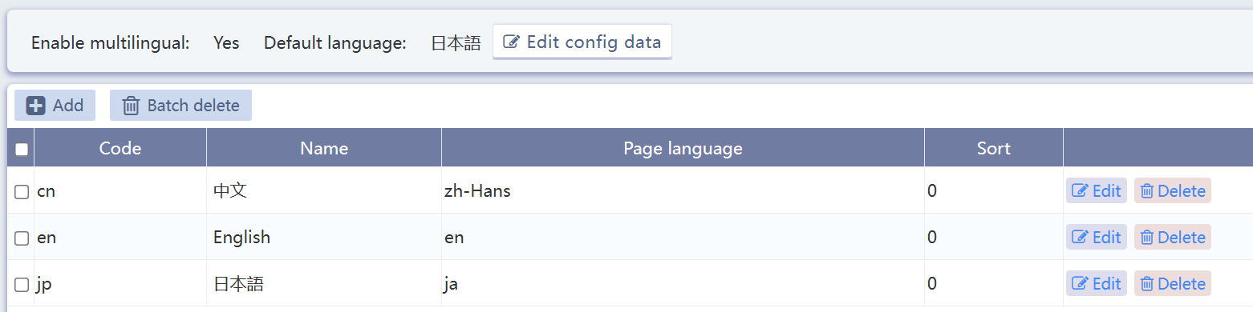
Then maintain different language versions of categories, content, page metadata, and page fragment recommendation data.
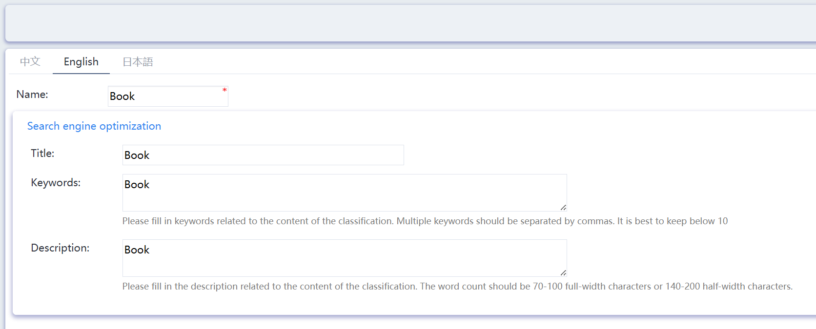
When creating templates, use data query commands that support multiple languages and add the language parameter lang=lang.
Add language tags to page elements.
Add language switch links in static page.
Or add language switch link parameters to any additional dynamic pages:
<a href="?language=jp">日本語</a>

Multisite mode
In site management, create multiple sites, create templates in different languages, and assign different administrators to maintain them. Then each site can achieve language switching directly through hyperlinks or js jump, wherein simplified Chinese, traditional Chinese are recommended to directly use js to implement specific Chinese character replacement for page text.

Multi-template directory mode
Create multiple directories in a template. Each directory is made in a different language. When creating categories ,you can use one or multiple categories based on the actual situation. When using a set of categories, it is required that each category must maintain material in multiple languages. You can use the extended field mode to expand material storage fields of multiple languages. Then maintenance personnel maintain materials of multiple languages for the same content or category. When multiple sets of categories are used, each set of templates uses its own independent category-content system ,which is maintained and managed in a unified background. The switching mode is similar to that of multiple sites.

Internationalized Template Naming Method
You can refer to the home page and Chinese home page examples in the background template management example. Internationalize and name the template. Then the template engine can realize international language switching
Full internationalized template name :index_zh_CN.html. index is the file name. zh_CN is the language identifier, and.html is the file suffix. The language identifier is divided into two parts: language and region. For example, zh and CN respectively identify Chinese characters.
add language switch link parameters to any additional dynamic pages:
<a href="?language=zh_cn">中文</a>
When locale is set to zh_CN and the user accesses index.html, the template engine preferently loads index_zh_CN.html, if it is not found, then loads index_zh.html, if it is not found, then loads index.html, if it is still not found or the template exists or the index.html template metadata does not have dynamic access enabled, and users get a 404 error.
Common language item
Languages | Language value
ENGLISH | en
UK ENGLISH | en_GB
US ENGLISH | en_US
CANADA | en_CA
FRENCH | fr,fr_FR
CANADA RENCH | fr_CA
GERMAN | de,de_DE
ITALIAN | it,it_IT
JAPANESE | ja,ja_P
KOREAN | ko,ko_KR
Chinese | zh
Simplified Chinese | zh_CN
Traditional Chinese | zh_TW

- Tips
When internationalized naming is used, dynamic access should not be allowed for the template metadata with language suffixes. The metadata obtained from the template is also the metadata of the template without language suffixes. For example, the metadata obtained from the index_zh_CN.html template is the metadata of index.html

Visual layout

Visual area management
Click Add or click existing area to modify, and fill in the name. If the area displays different layout modules for different category pages, you can choose to bind category types. If the visual area binds a category type, when the visual region is invoked , the category id parameter for that category type should be passed

Visual layout management
Click Add or click the existing area to modify, fill in the name, modify the layout related html, click the "Insert Position" button in the appropriate location, Insert the code ”<#-- position -->”. When the page is rendered, this code will be replaced by the visual module reference code corresponding to the location; To modify the style, click and Insert CSS selector in front of these stylesheets and prefix them with the code "/* selecter */". This code under Page -> Page visualization is replaced with a specific stylesheet prefix to ensure that the style affects only the portion of the visualization area layout that the staff sees.
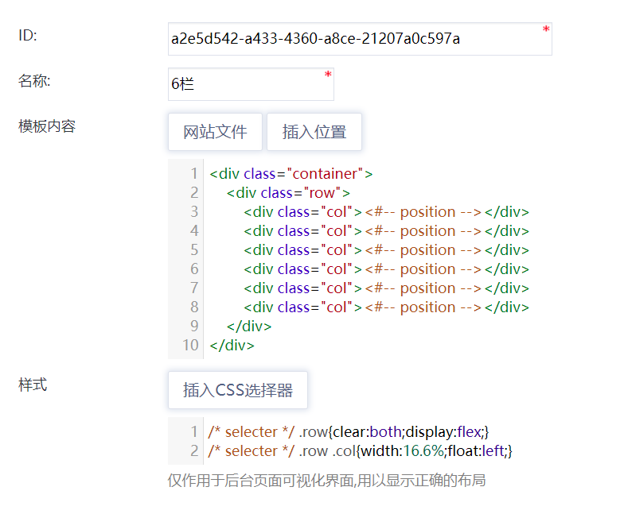

Visual Module Management
Click Add or click the existing area to modify, fill in the name, upload the cover image, and select the corresponding page fragment; Cover image only display effect when preview the module under Page->Page visual configuration . When the Copy check box option is checked, the visualization module copies one piece of the page each time it is used in a different visualization area.
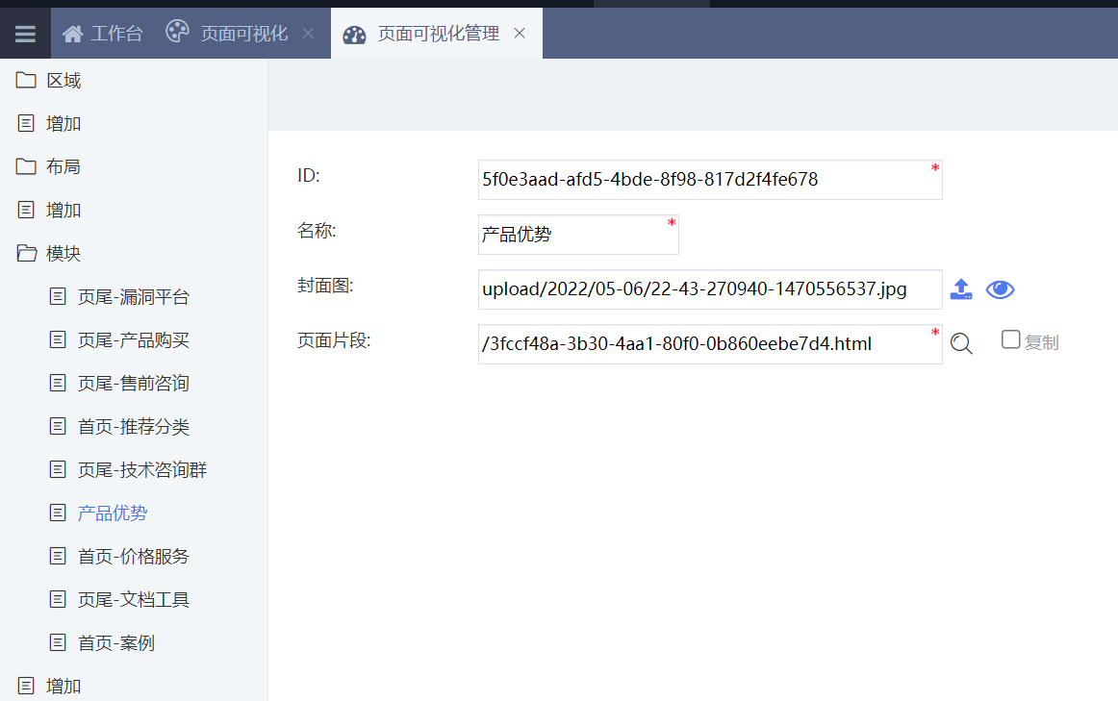

Visual area configuration
Select the visual area for maintenance, first drag the layout in the blank visual area, then drag the module to a different area of the layout; It can also adjust the existing layout and module sequence of the visualization area. Click the button of the maintenance function of the existing module for data maintenance
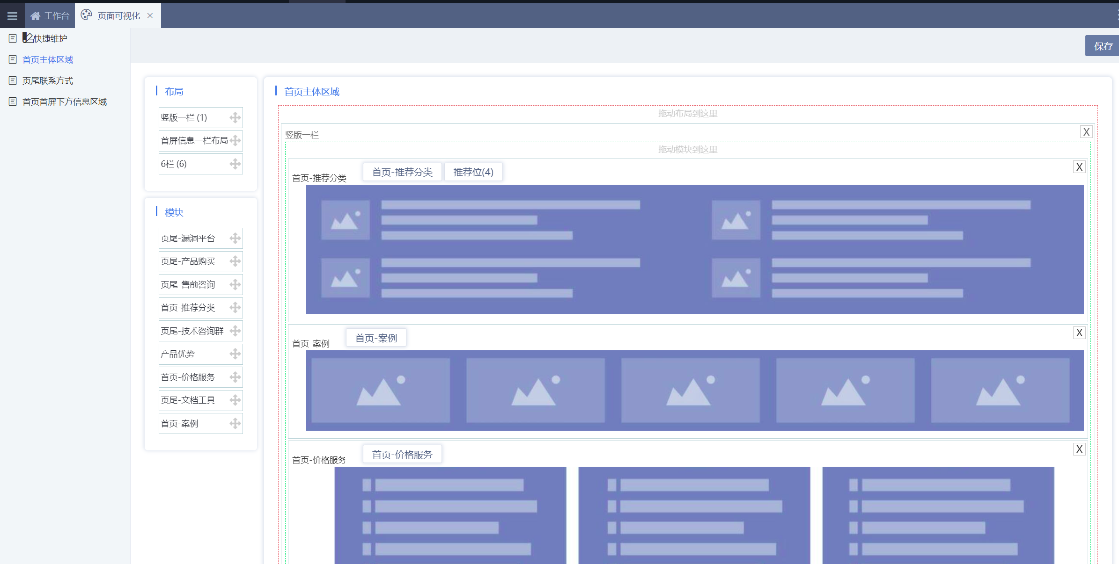

Quick Maintenance

Quick maintenance driver code
Visual page layout supports need the definition of itemString (content page, category page and other pages with corresponding data items) and templatePath and the introduction of js
<script>
var itemString="itemType=category&itemId=${category.id}";
var templatePath='${.current_template_name?keep_after('/')}';
</script>
<script src="${site.dynamicPath}resource/js/cms.support.js"></script>
- Function menu
Add diy tags to the page elements in the template
data-diy="category" data-diy-id="${(category.id)!}"
The values of data-diy and data-diy-id support:
data-diy | Function menu | itemTyp appliese | data-diy-id | value of data-diy-id
category | Category Management | All | optional | Category id
comment | Comment Management | content | NA
content | Content Management | content、category | optional | Content id
child-category | Subcategory Management | category | NA
page | Page Management | All | NA
region | Visual Management | All | Required | Area id
place | Page fragment Management | All | Required | Page fragment path
user | User Management | All | optional | User id
config | Configuration Management | All | optional | Configuration item coding
task | Plan task Management | All | NA
- Function button
Add diy tag to the parent element , and add diy-item tag to the children elements
<@cms.categoryList>
<ul data-diy=”category”>
<#list page.list as a>
<li data-diy-item=”${a.id}”><a href=”${a.url}”>${a.name}</a></li>
</#list>
</ul>
</@cms.categoryList>
The values of data-diy and data-diy-itemsupport:
data-diy | Function button | value of data-diy-item
category, child-category | Edit category | Category id
comment | Edit comment,Reply comment | Comment id
content | Edit content | Content id
place | Edit recommend data | Recommend data id
user | Edit user | User id

Quick maintenance
Click to enter the website quick maintenance mode. When you visit different pages in this window, the upper menu will be dynamically numbered. You can also use the mouse to row over the maintainable elements of the webpage, and the corresponding menu will pop up. Click the menu item to quickly manage the relevant data or content of the website
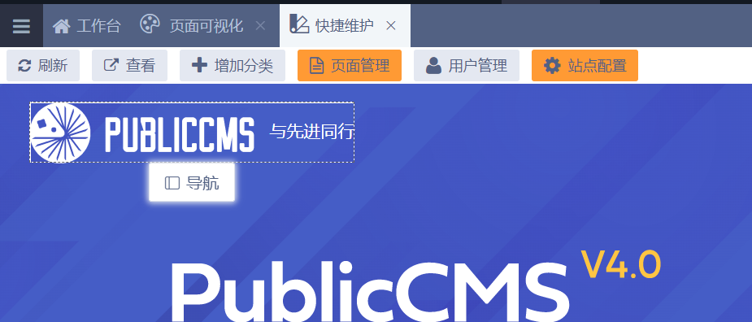

Website Access Statistics
Website access statistics support needs to define itemString (content page, category page and other pages with corresponding data items), introduce js, and call statistical code
<script>
var itemString="itemType=category&itemId=${category.id}";
</script>
<script src="${site.dynamicPath}resource/js/cms.support.js"></script>
<script>
var ca = cmsAnalytics();
var url='${site.dynamicPath}api/visit/record';
if("string" ==typeof itemString){
url=url+"?"+itemString;
}
ca.setDomain('${domain.name}');
ca.setPath('/');
ca.report(url);
</script>

Technical support

Free Technical Support
Public CMS official website：https://www.publiccms.com/
QQ communication group：191381542 , 481589563 , 638756883
Freemarker files：http://www.kerneler.com/freemarker2.3.23/
Online debuggingFreeMarker：https://www.sanluan.com/freemarker_test.html

Commercial Technical Support
You can get commercial technical support after buying the software usage authorization, and you can also buy the commercial technical support service alone.

